# Validation Scripts

# Source data

Use H2 to create relational database

Change H2 to server mode (in cmd)

• Enter the H2 installation directory: cd "C:\Program Files (x86)\H2\bin"

• Change the port and start the H2 server: java -jar h2-2.3.232.jar -tcp -tcpAllowOthers -tcpPort 8083

• The JDBC URL is jdbc:h2:tcp://localhost:8083/~/test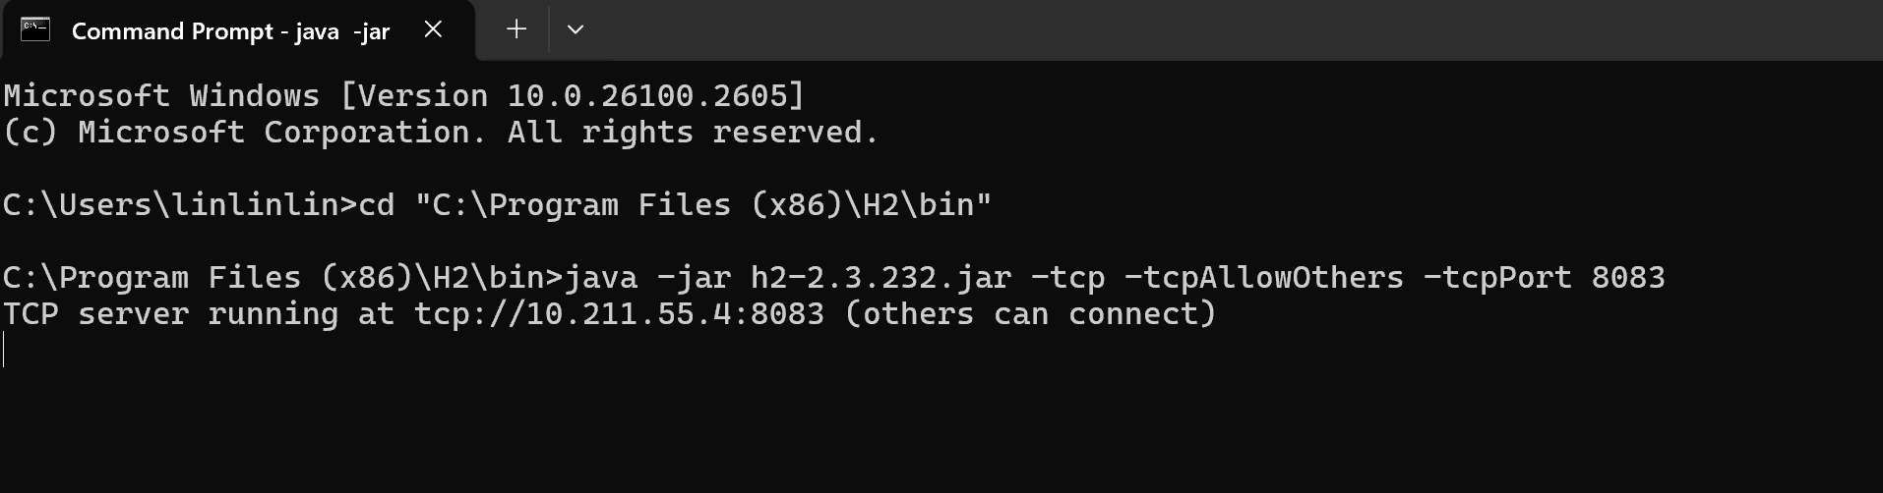

Login link: <http://localhost:8082> or

[H2 Console](http://10.211.55.4:8082/login.jsp?jsessionid=f25e81088b16a397004c3d35fe98b0e7)

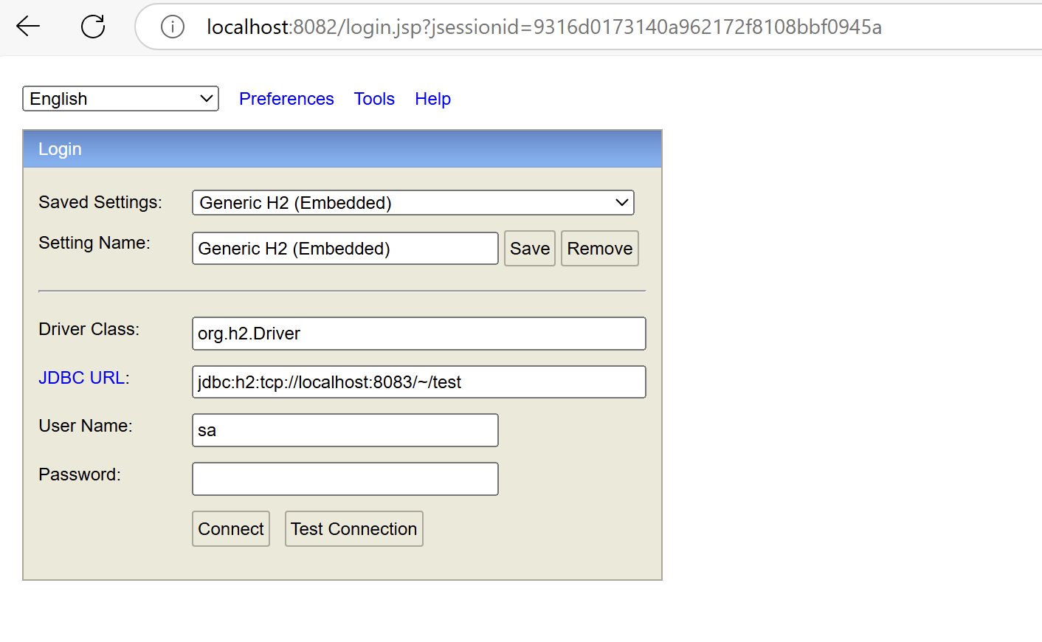

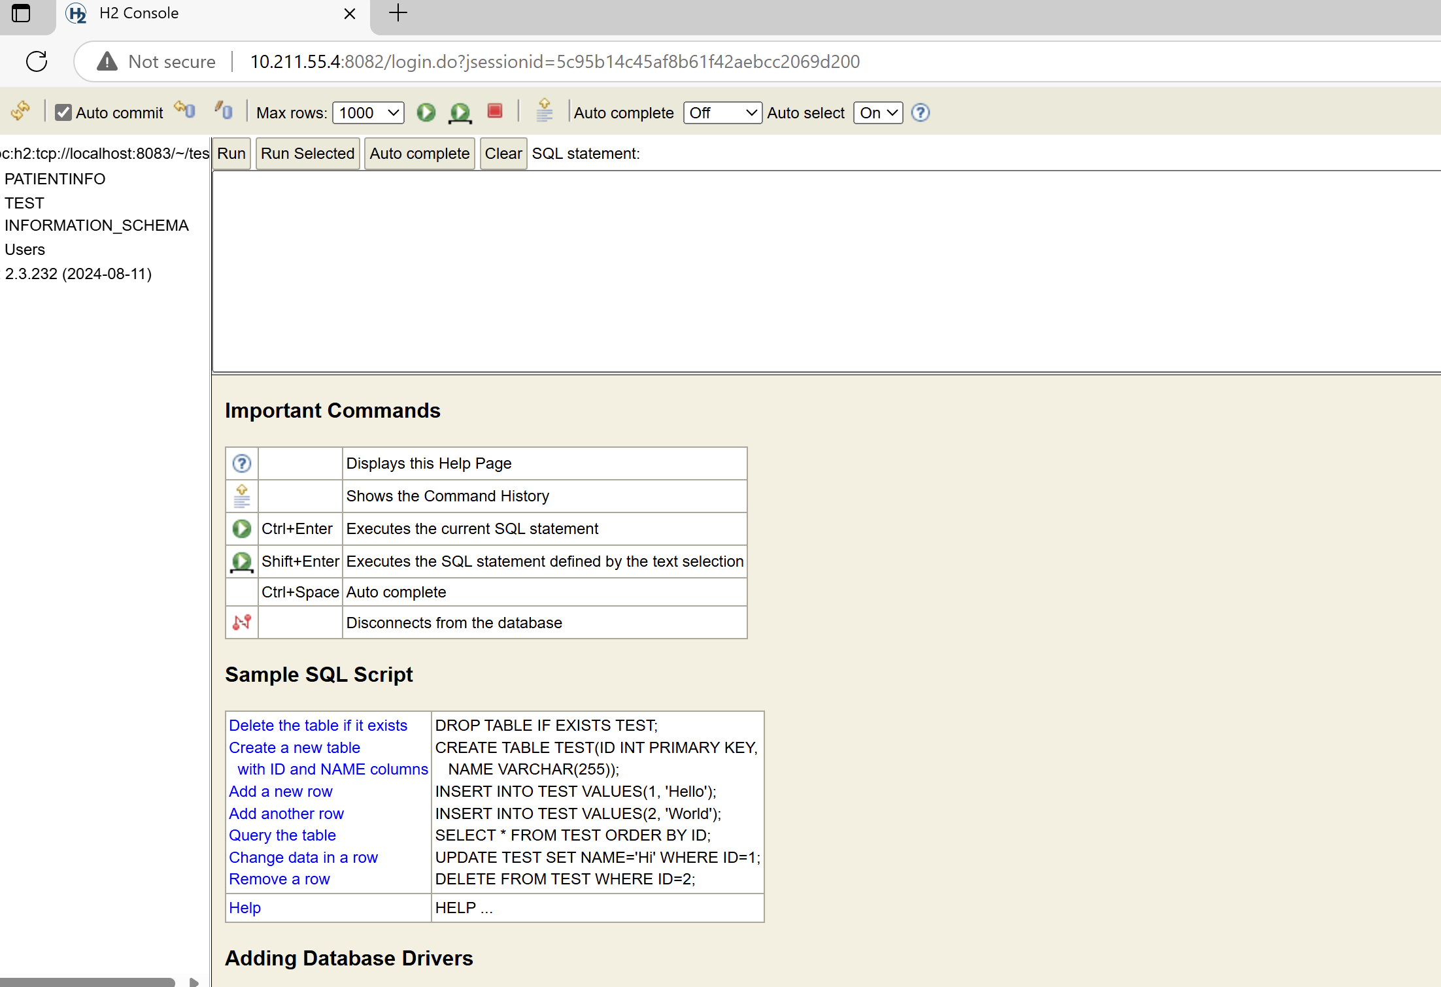

Create dataset “allpatientinfo” as the demo dataset

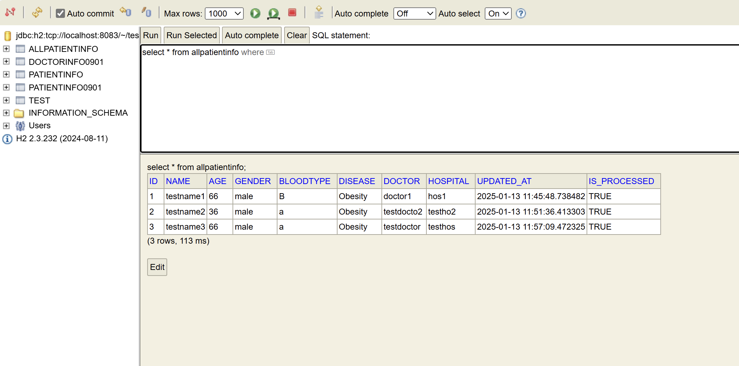

Create dataset “patientinfo” as the one track incremental data

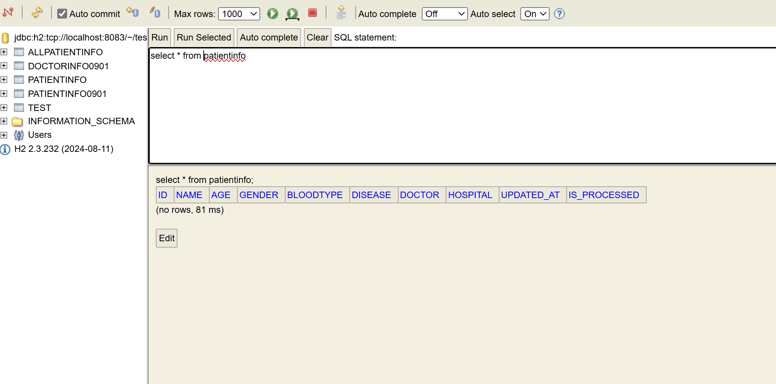

It is possible to make a more complicated dataset, such as 2 tables are connected via foreign key.

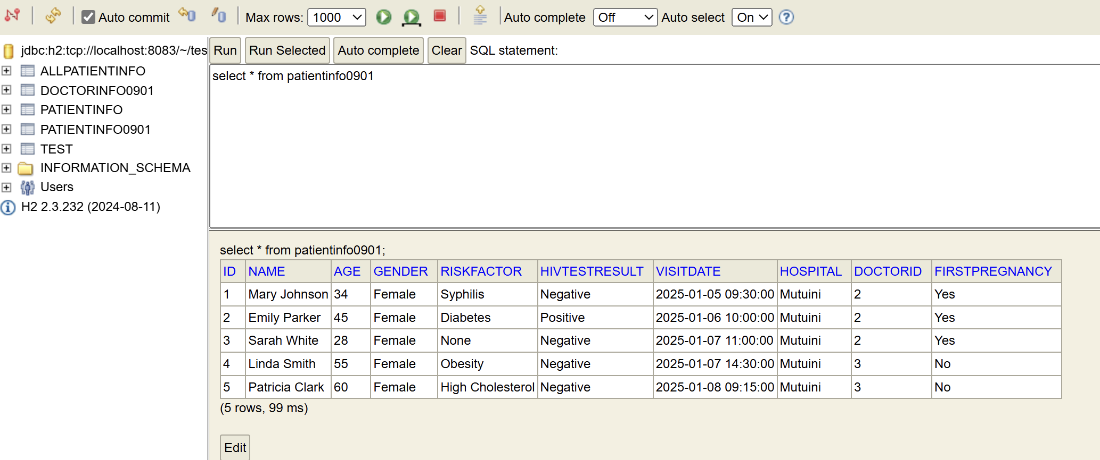

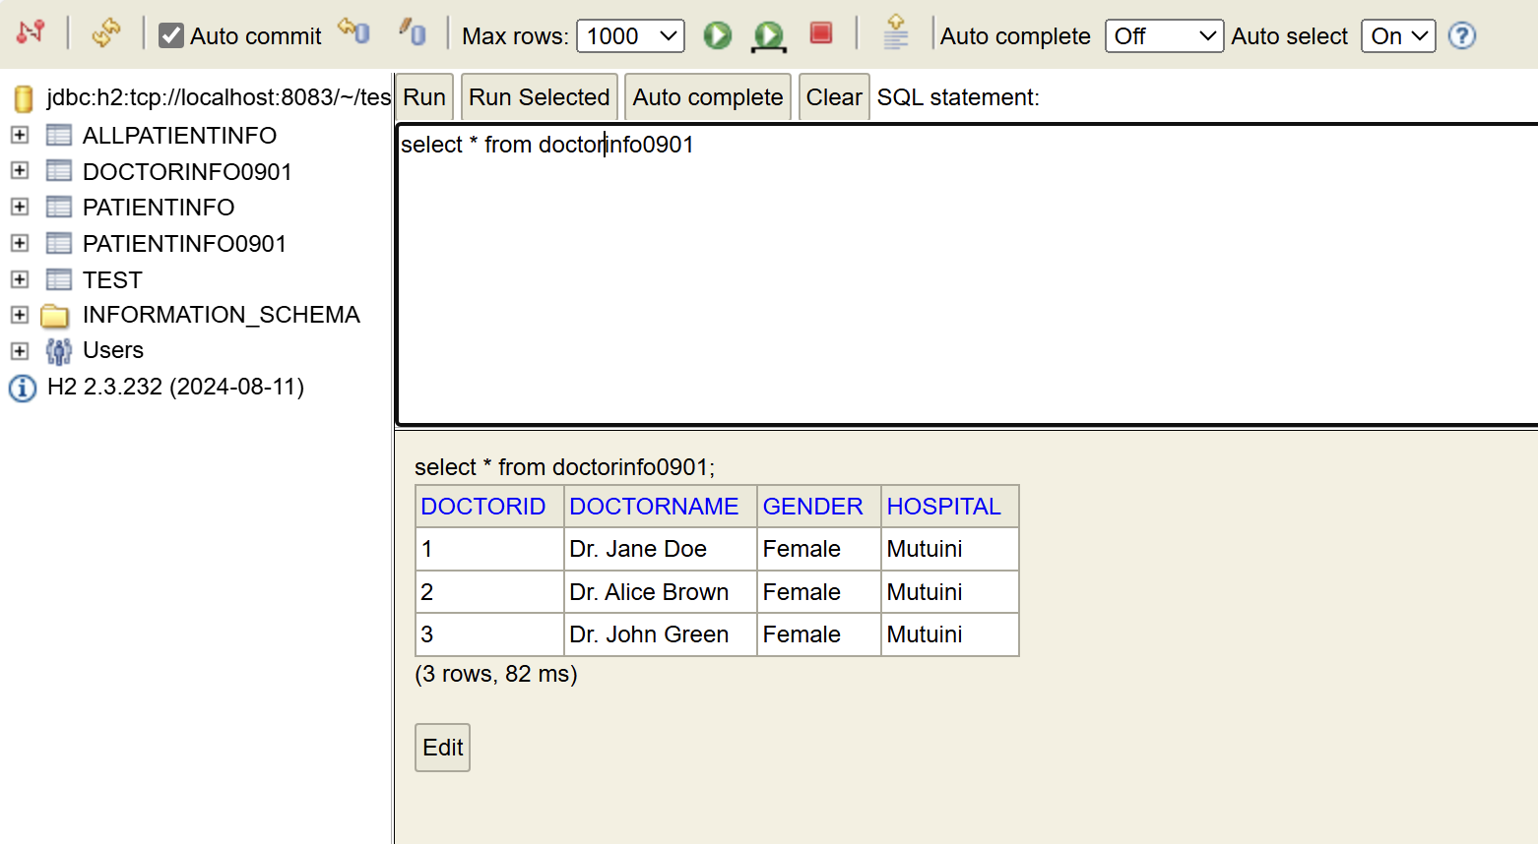

# Ontology

To validate the proposed ontology product, I use Protégé to create ontology. If users do not need new ontology, this step can be skipped.

Protégé link：<https://protege.stanford.edu/software.php#web-protege>

For convince，I use the web version.

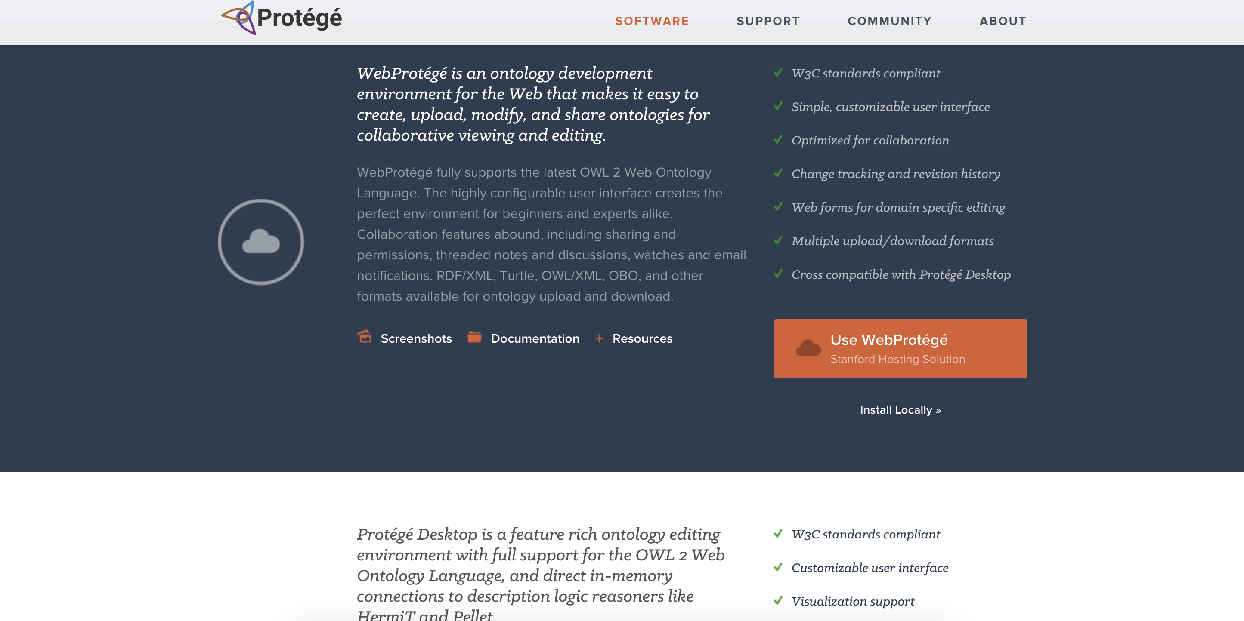

Based on the dataset defined in the database, I create my ontology.

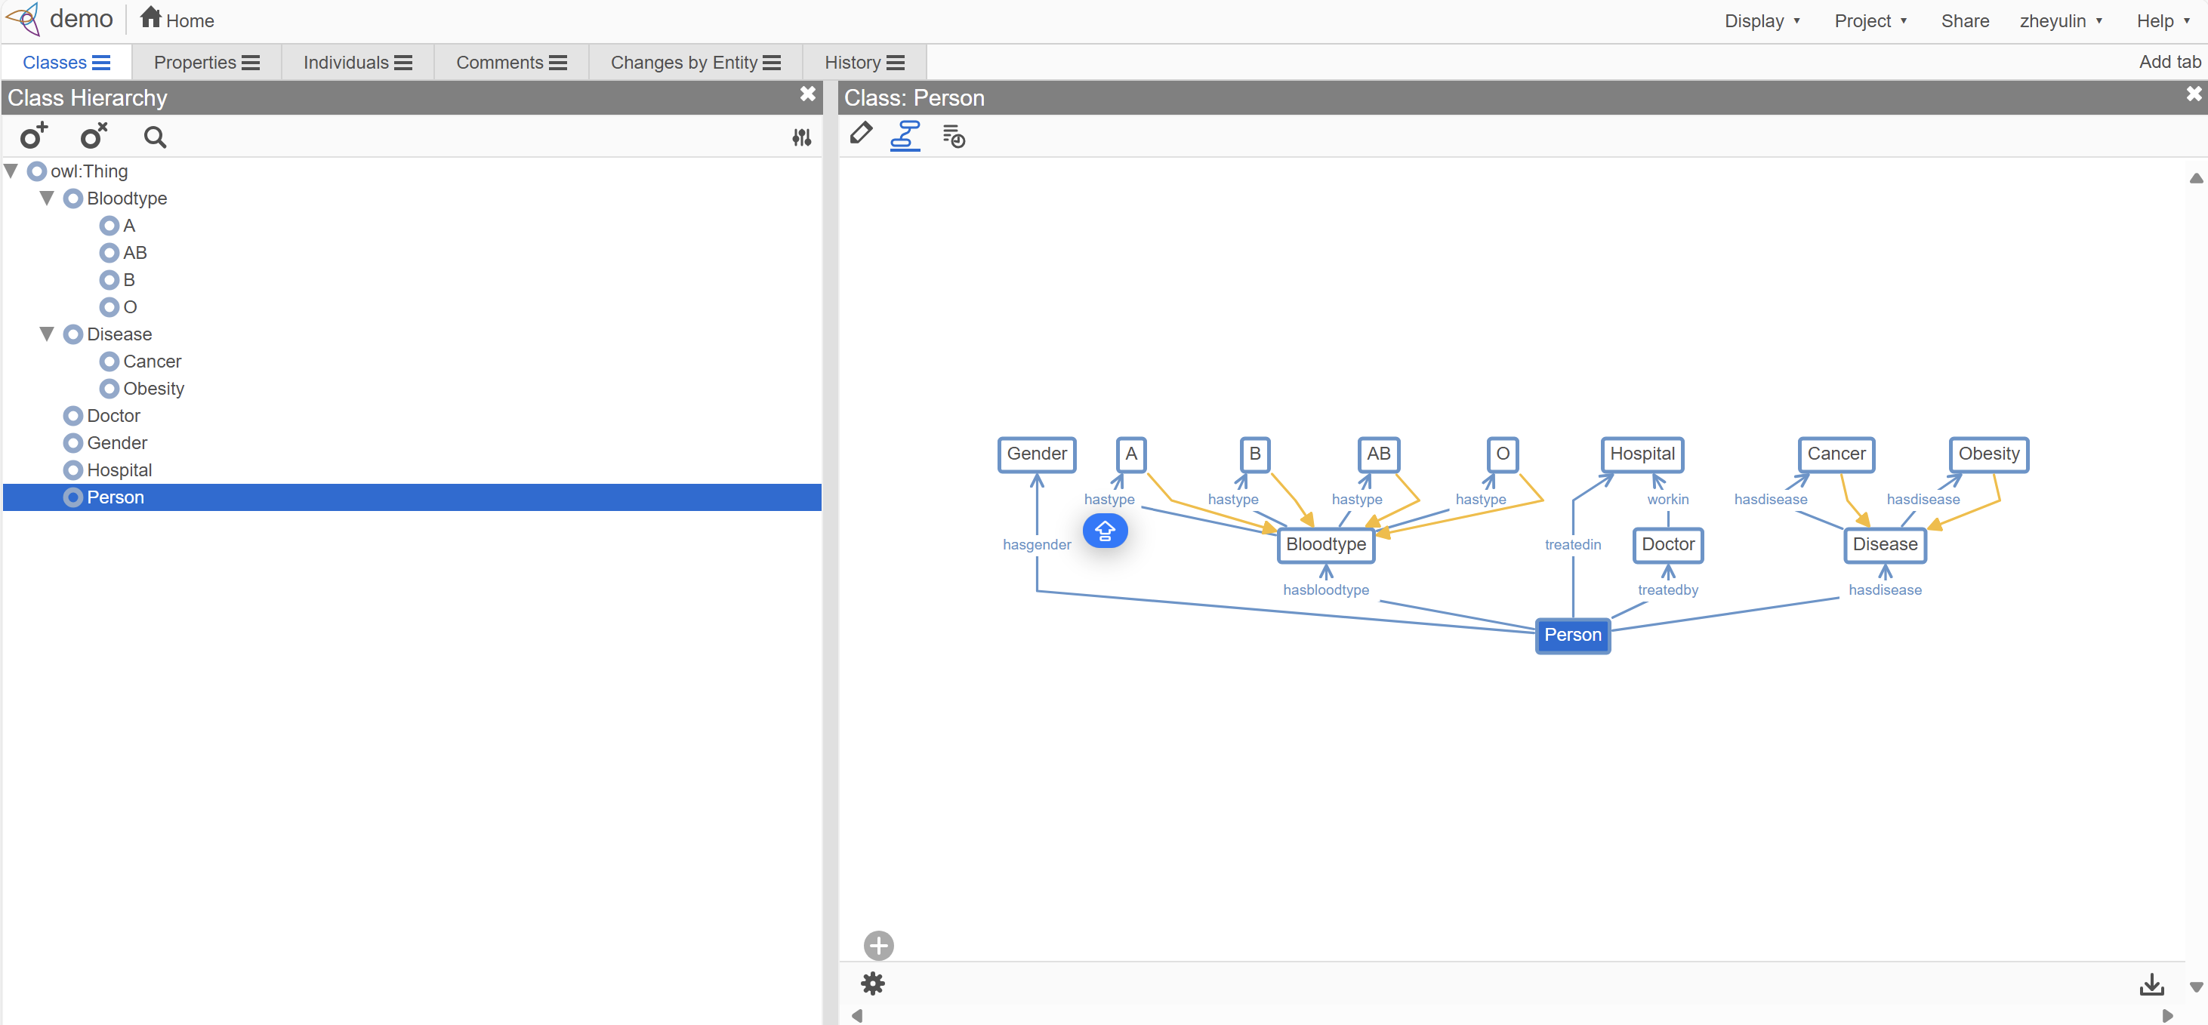

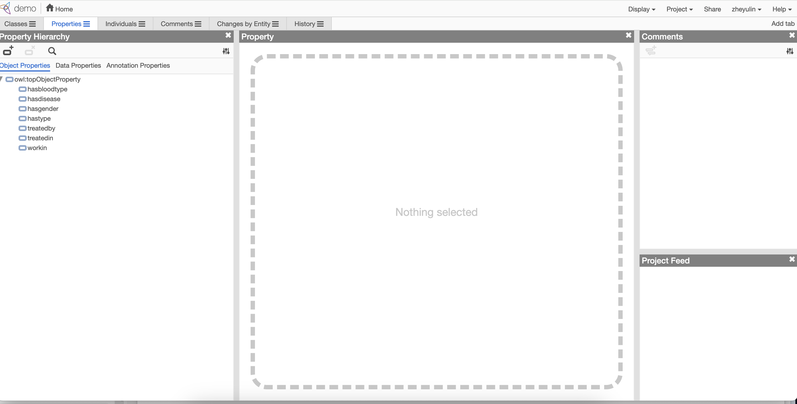

After creation, I upload it to BioPortal.

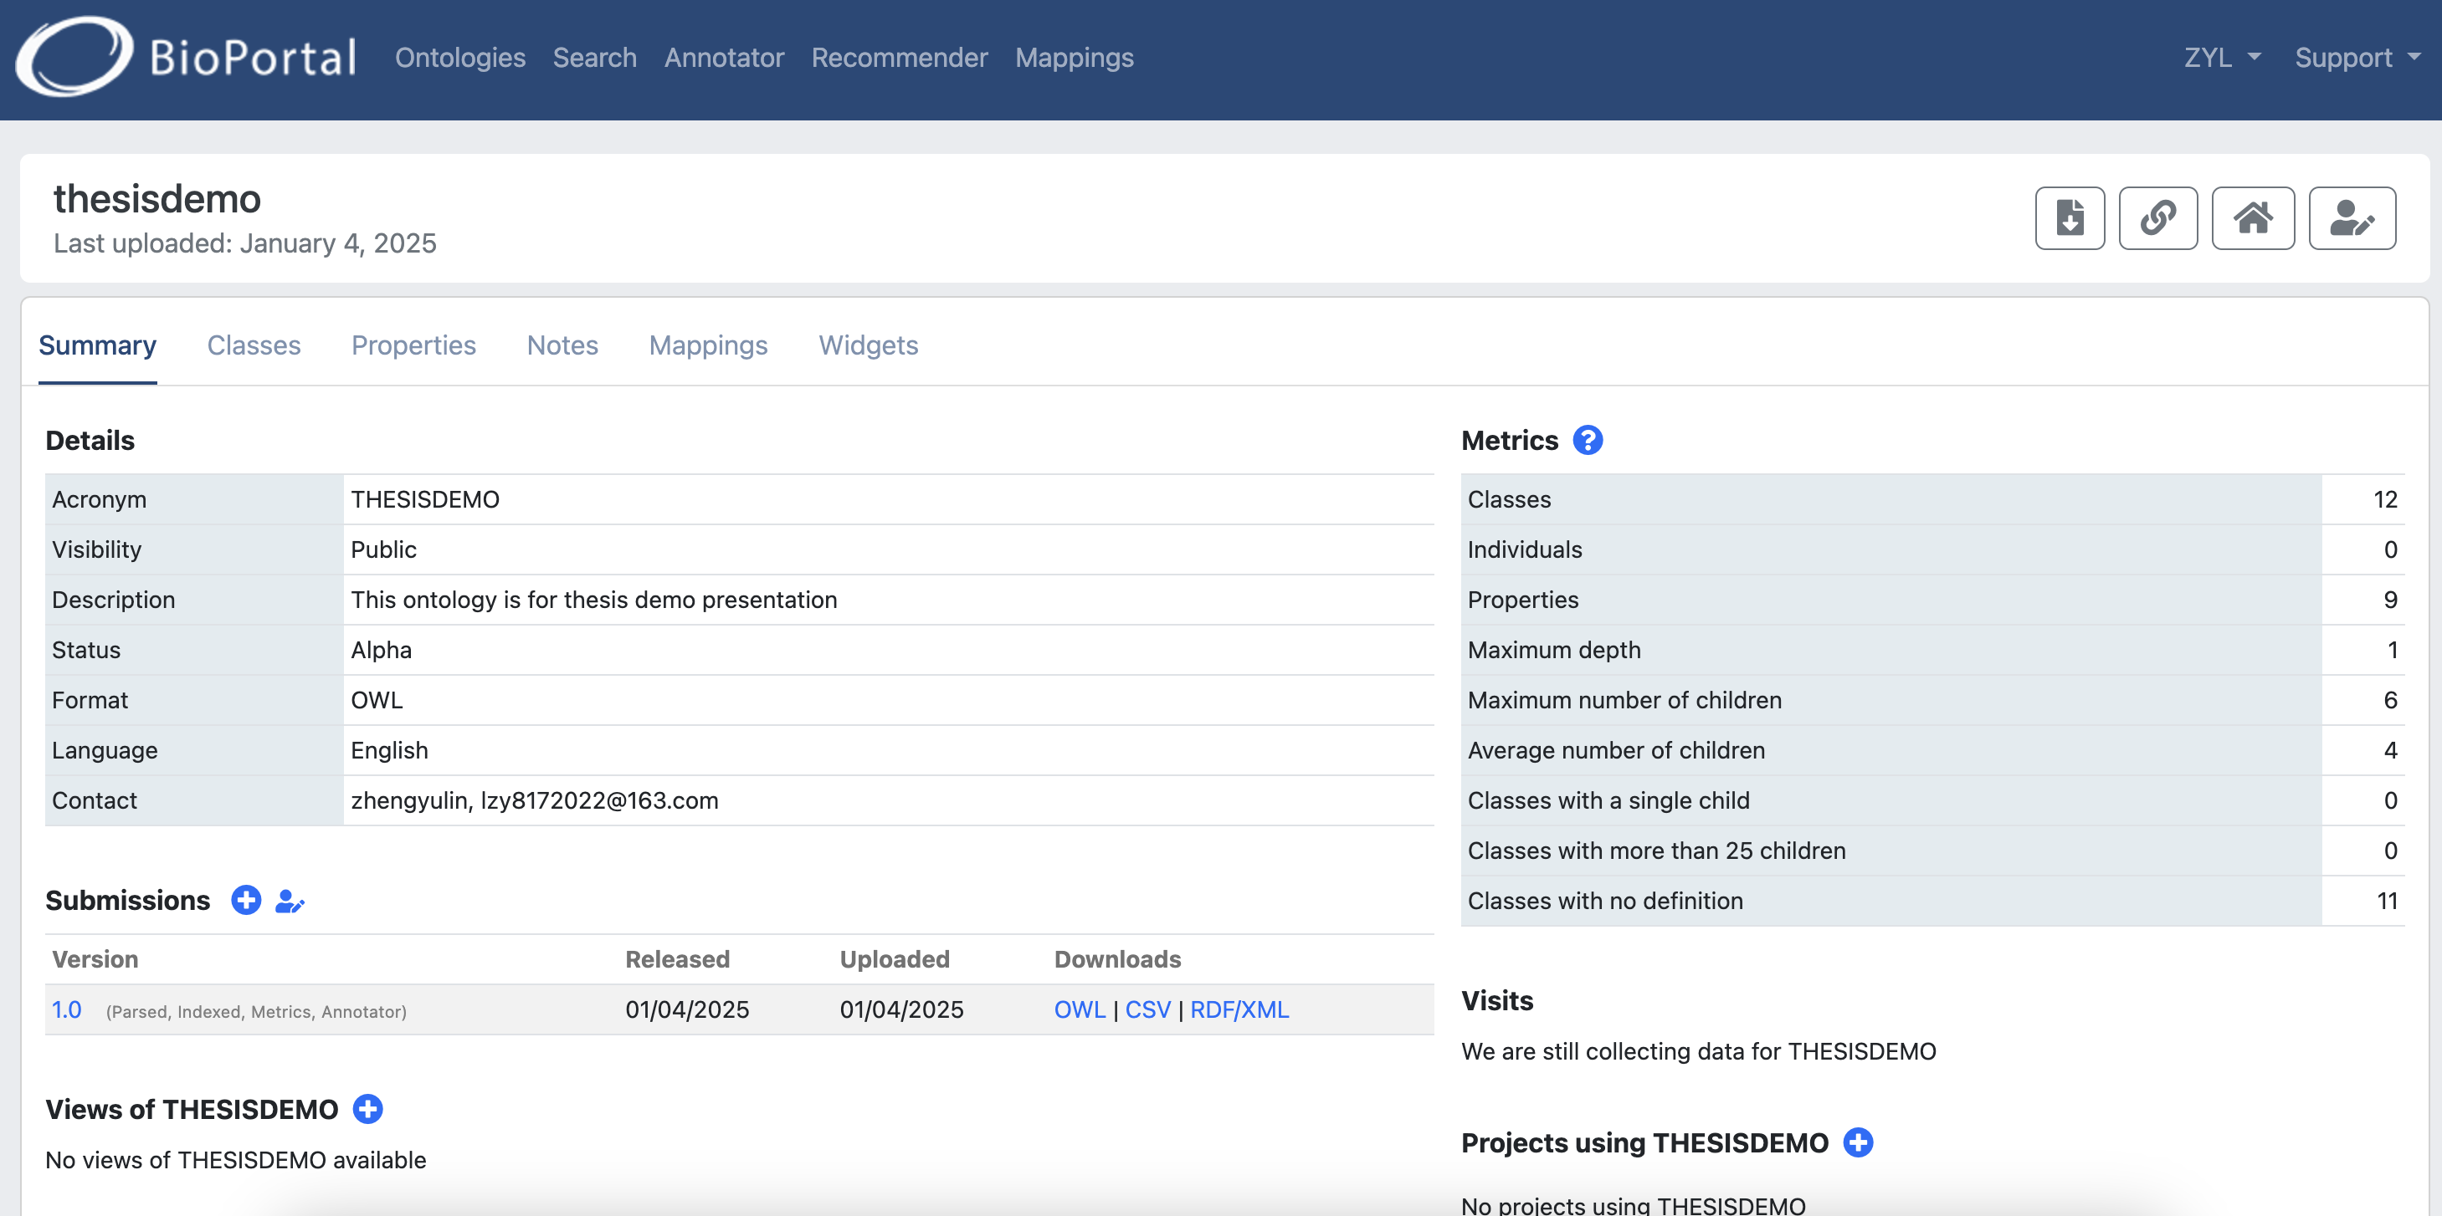 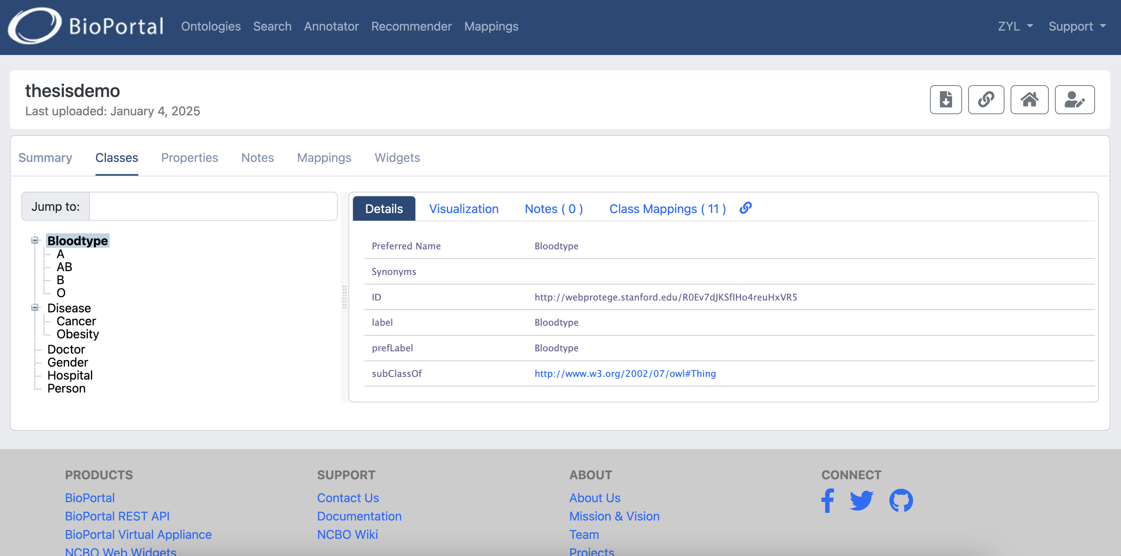

Finally, download the ontology which will be used in next steps.

# Mapping rules

Ontopic Studio can be found here

<https://ontopic.ai/en/ontopic-studio/>

## Source database connection

I set up parameters connect Ontopic Studio and H2. This step ensure that Ontopic Studio could read the data stored in H2 automatically. Even if there are some data changes in H2, Ontopic Studio can read the updated data automatically which can be shown in the video “Automatic data update in Ontopic Studio”.

The driver and username are same information used when log in the database.

However, connection URl is a bit different. I add “FILE_LOCK=SOCKET ”at the end of the URL. It can ensure the file will not be locked during use.

So the connection: jdbc:h2:tcp://localhost:8083/~/test;FILE_LOCK=SOCKET

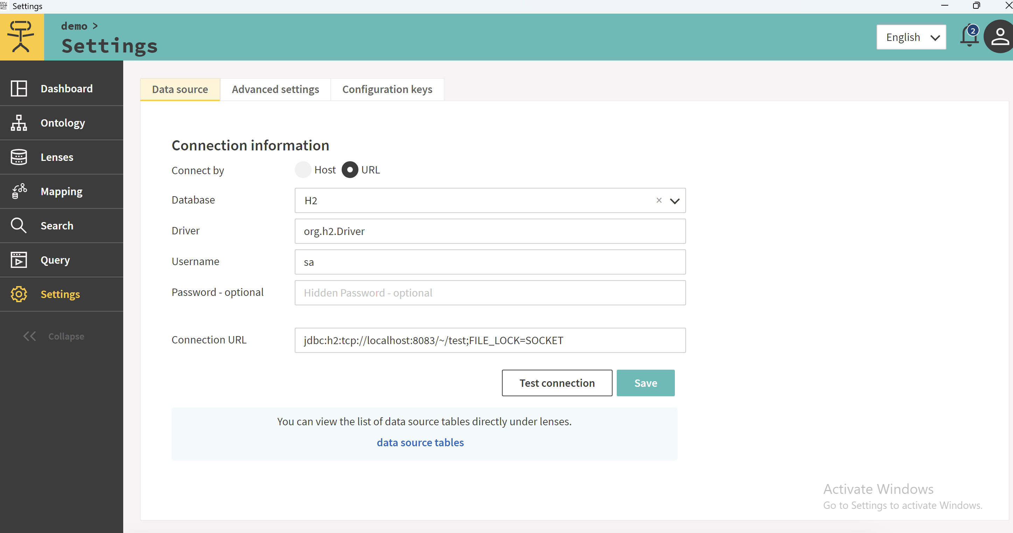

Data can be viewed in “Lenses” tab.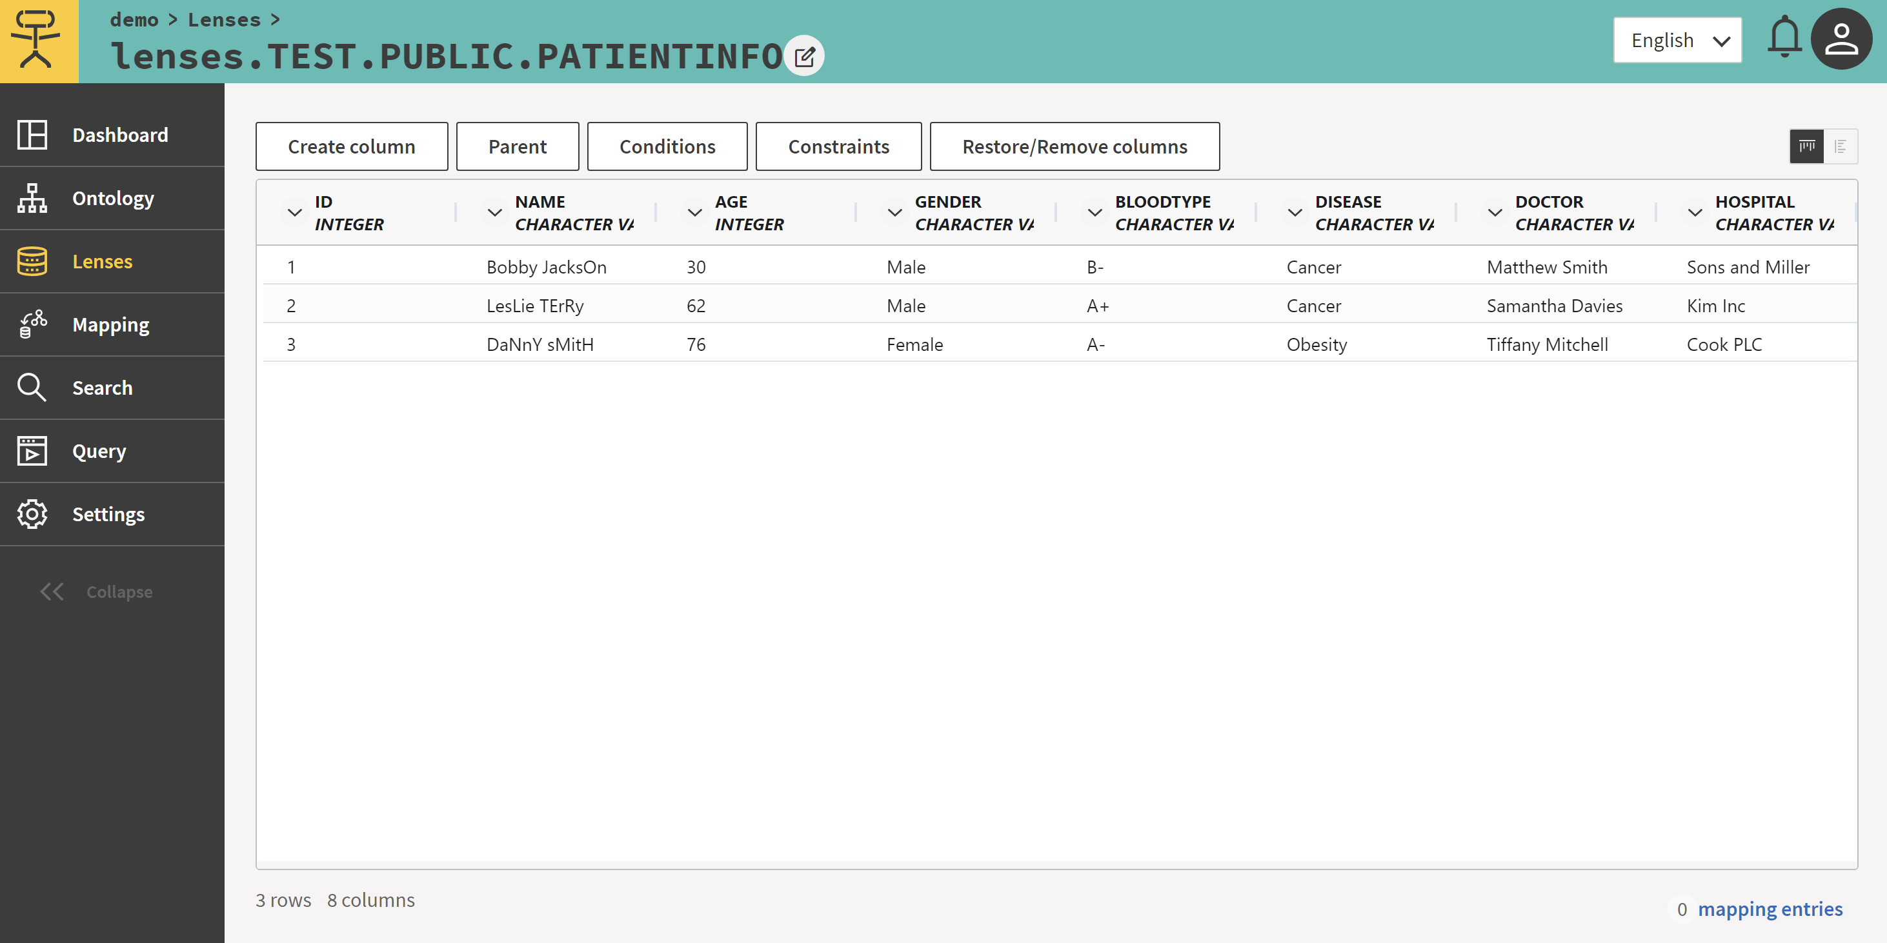

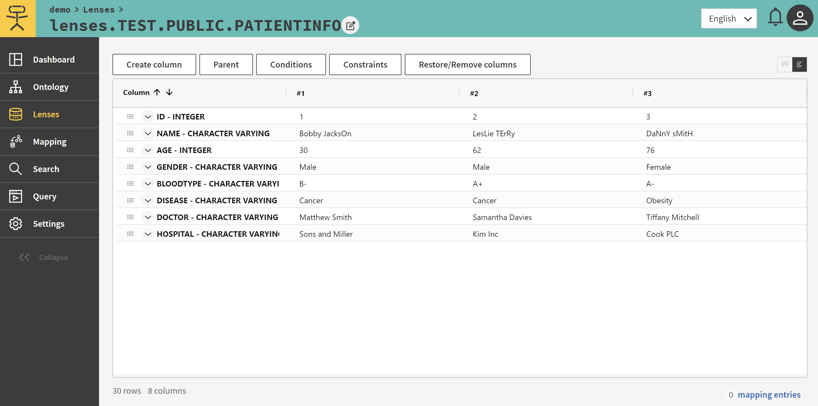

## Ontology upload

To set the mapping rules by mapping the source data to ontology, I upload the ontology created by myself into Ontopic Studio.

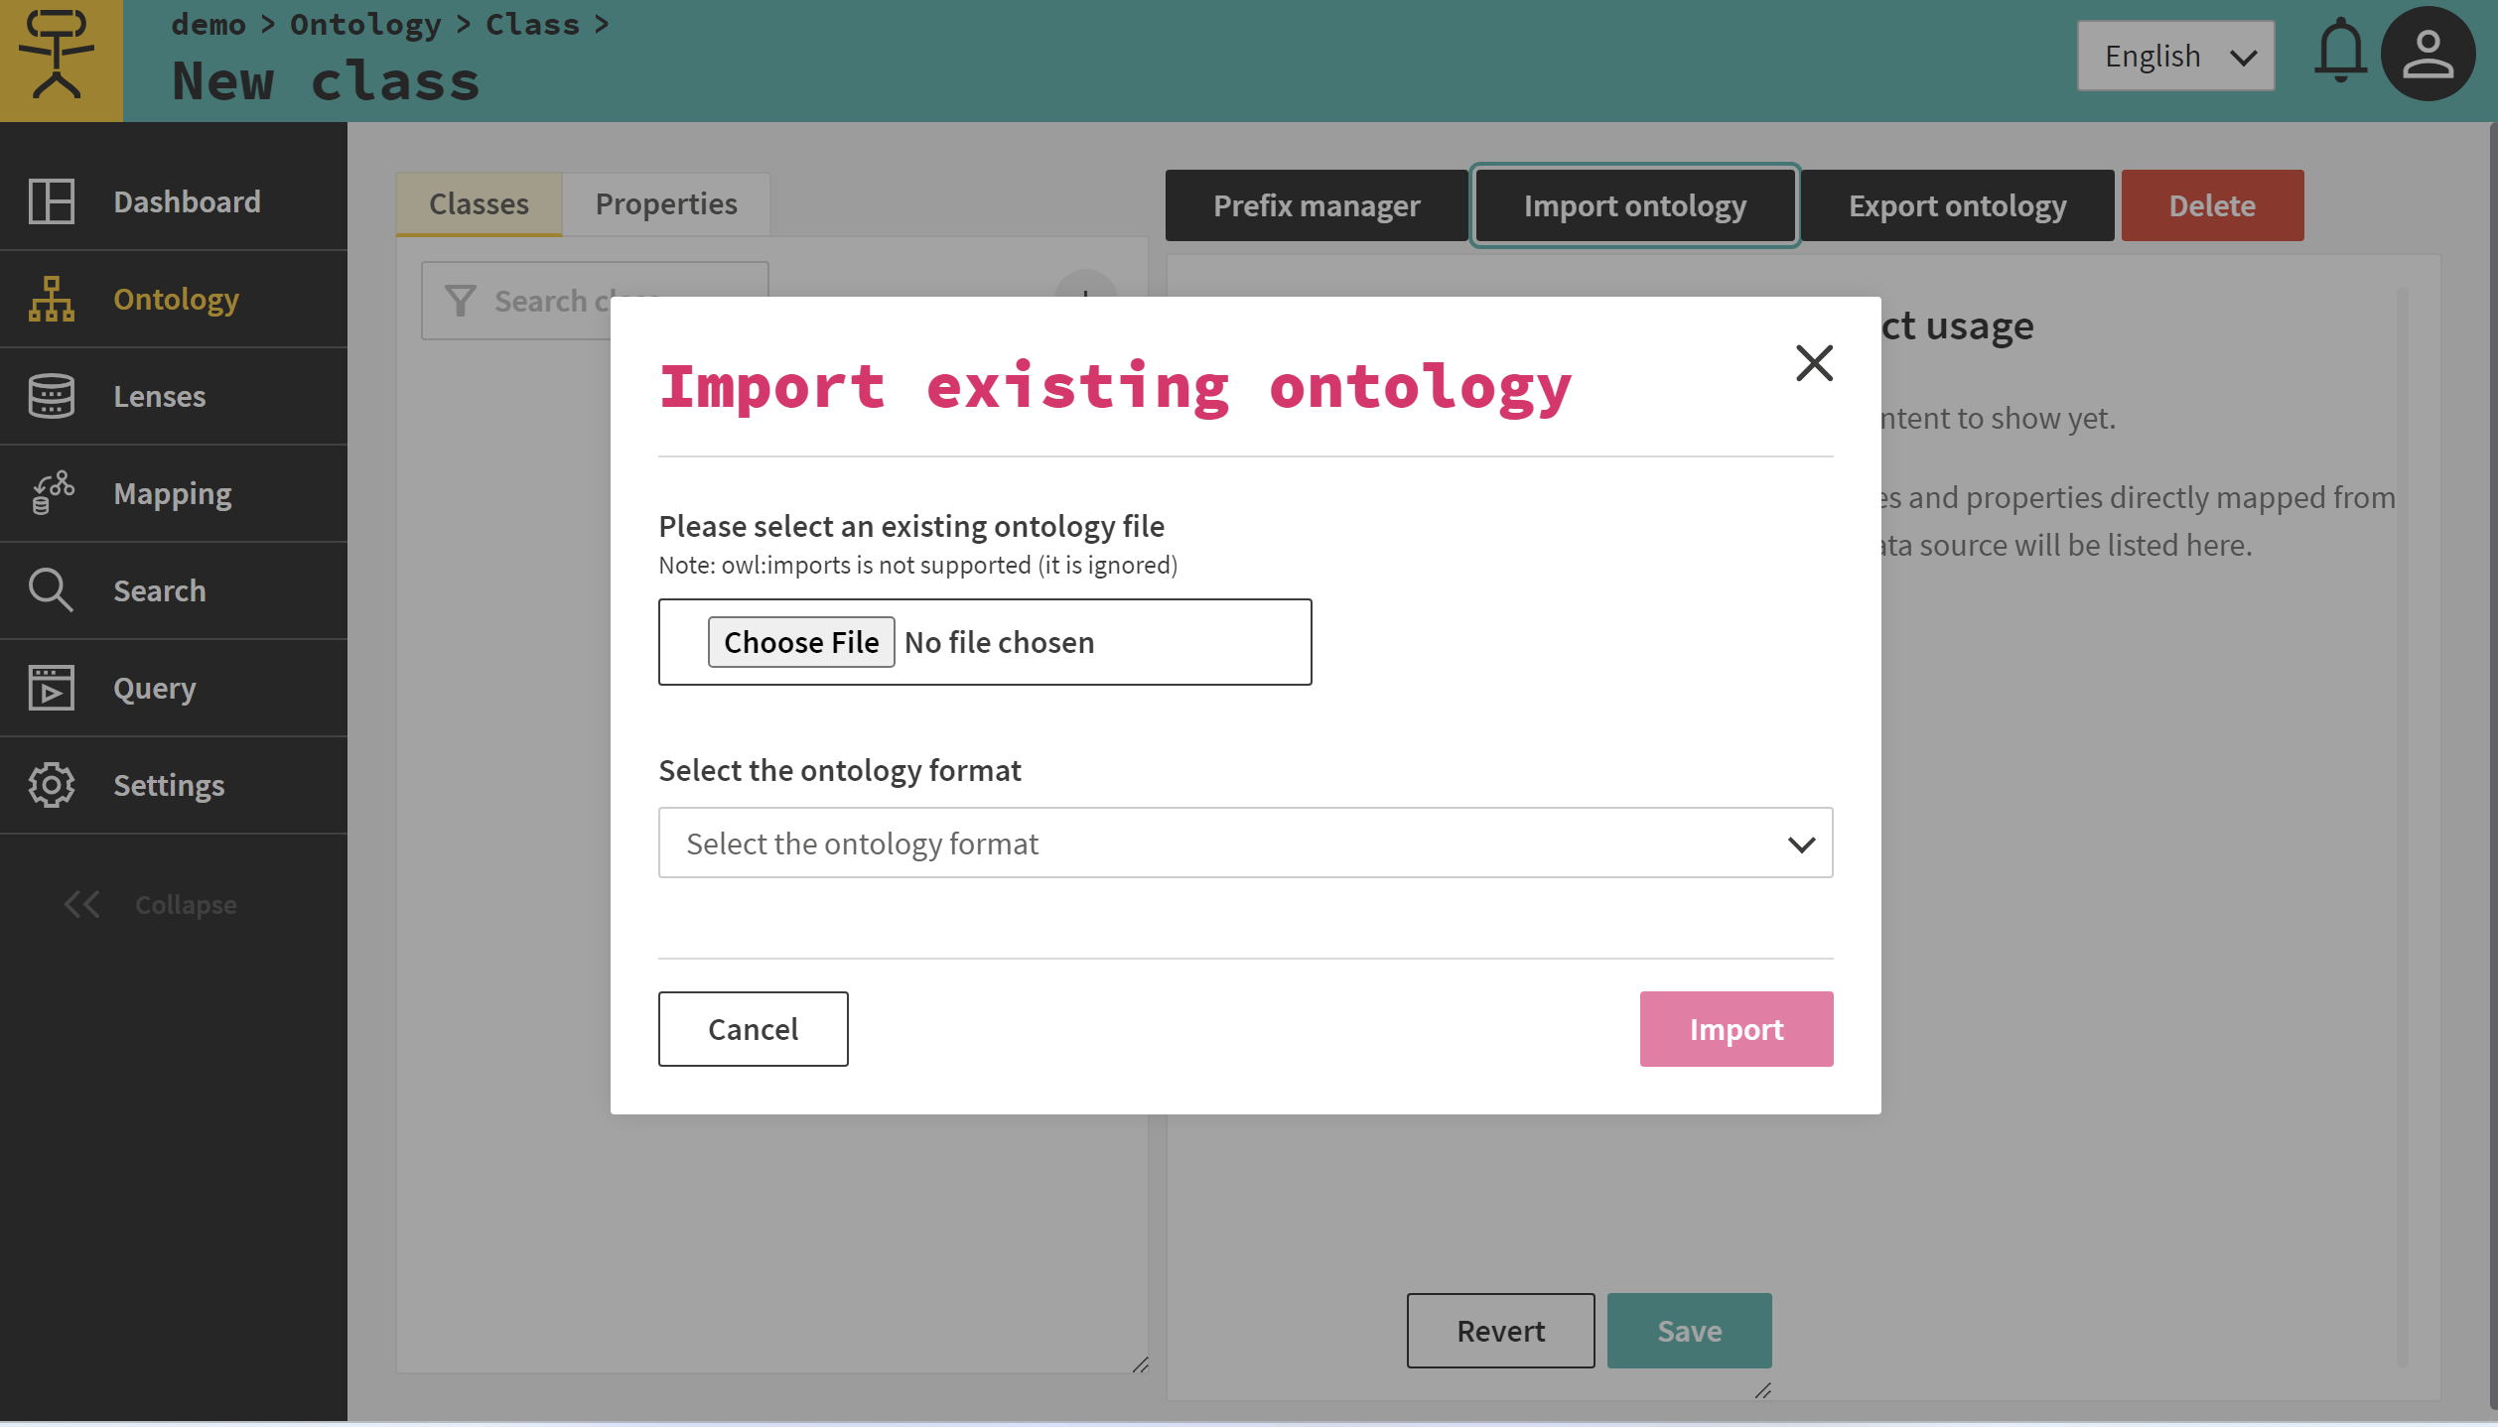

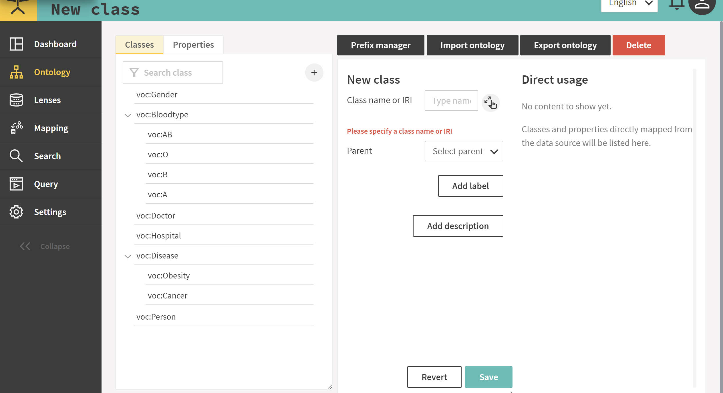 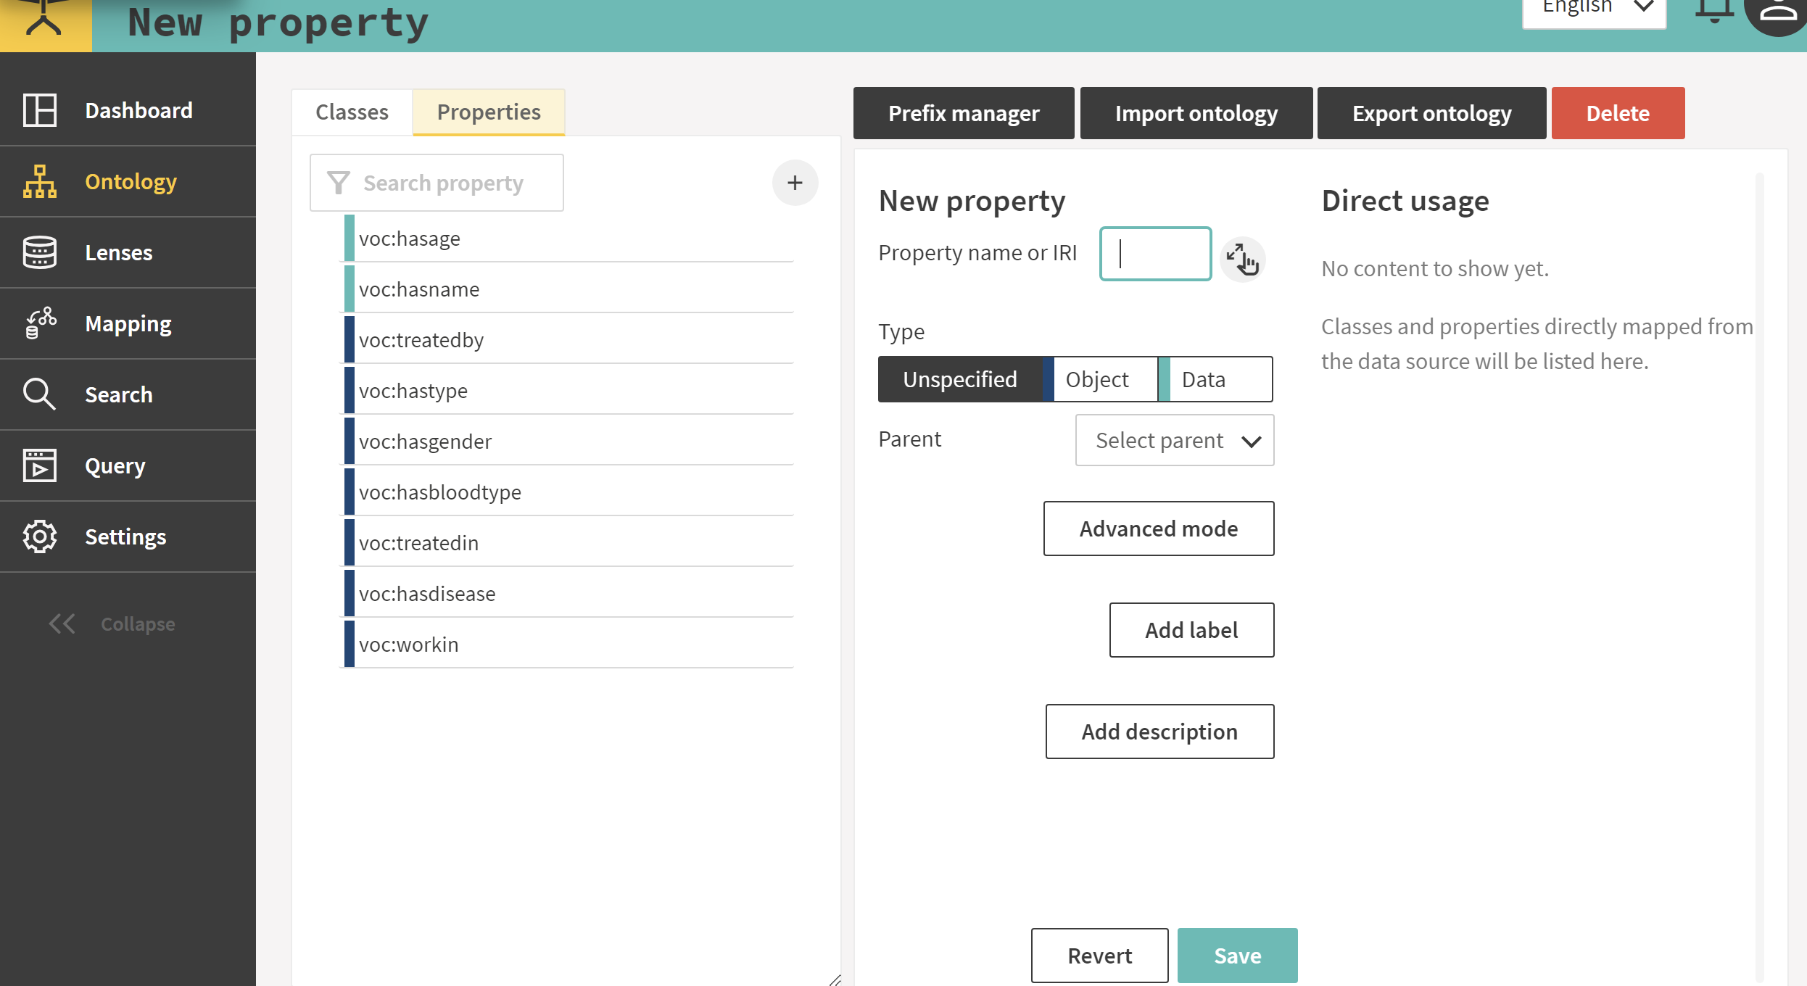

## Set mapping rules

The official support document can be found here:

<https://docs.ontopic.ai/studio/learn/quickstart.html#creating-lenses>

Here is the example indicating how I set the mapping logic.

First, choose the dataset and click “Generate Mirror Lenses”.

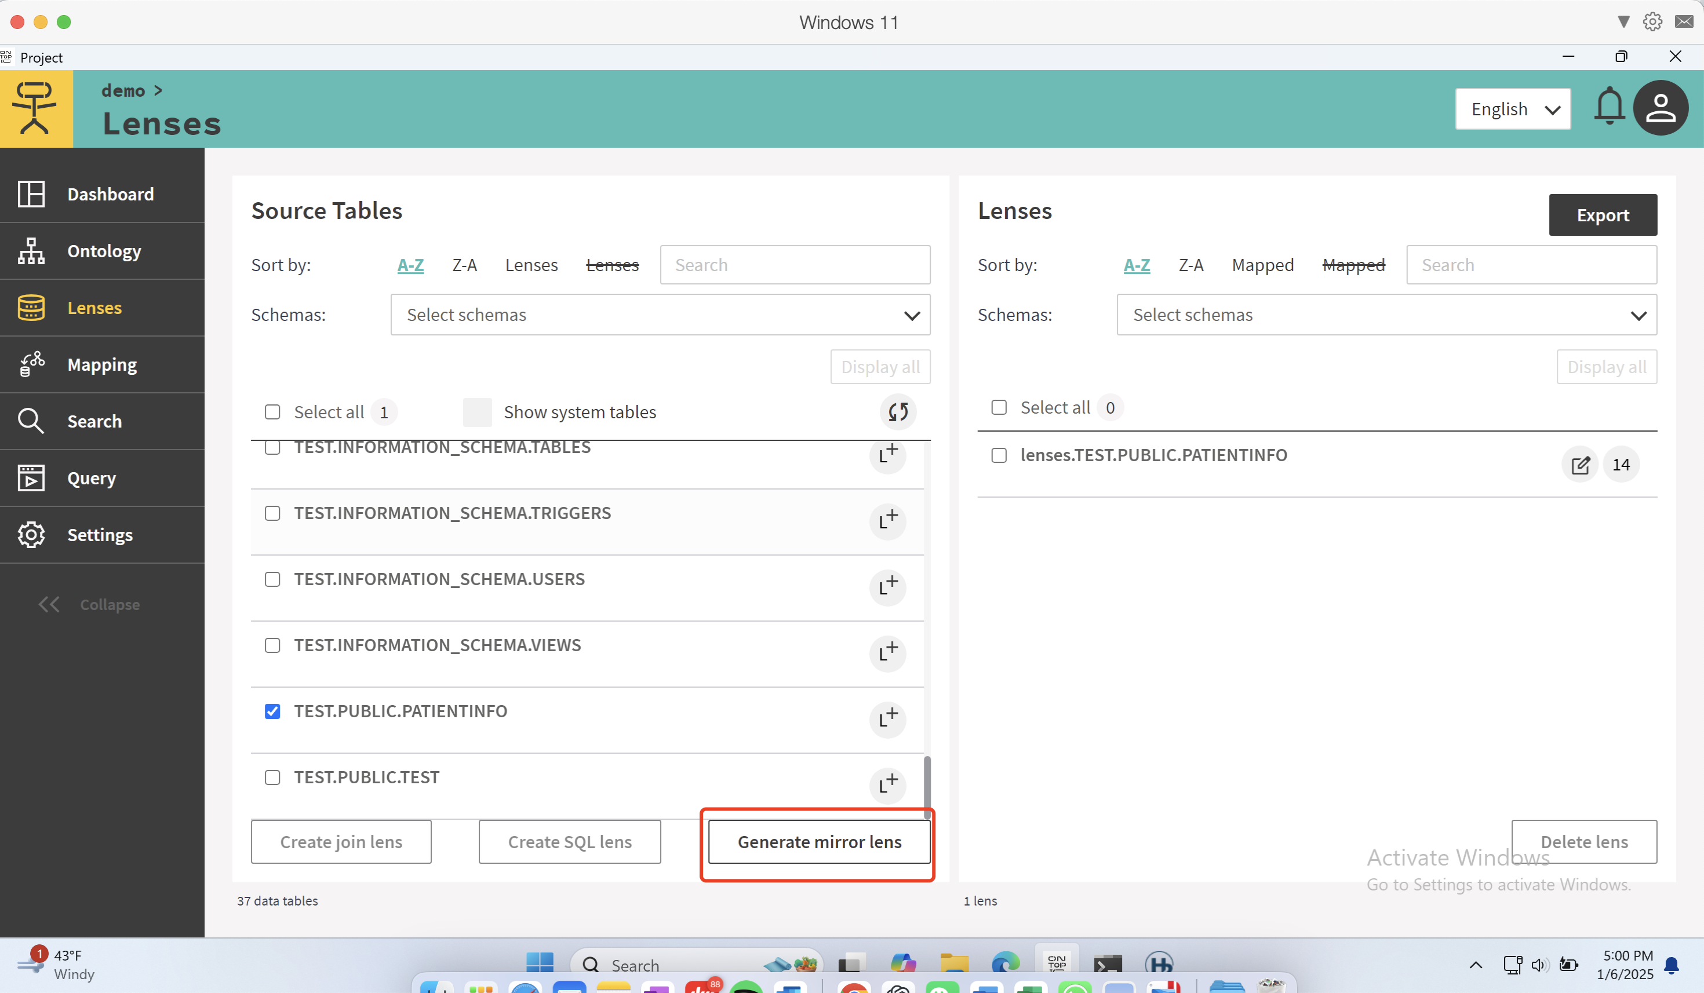

Then, come to the “Mapping” tab and enter the dataset.

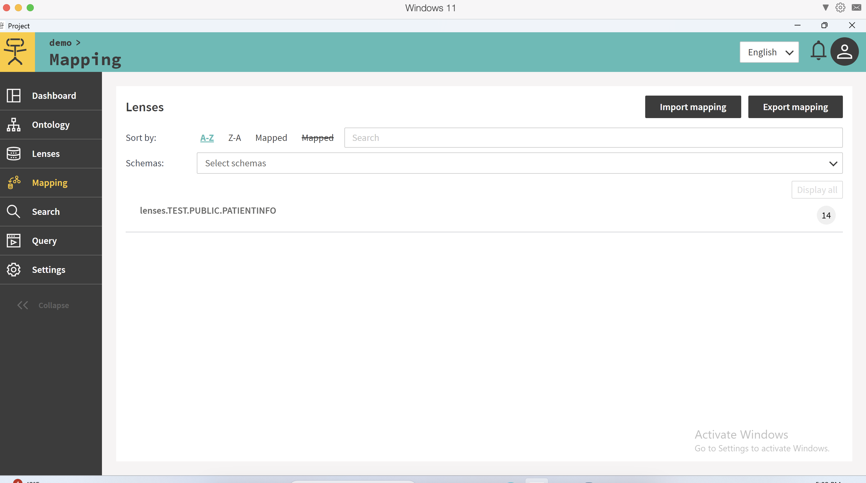

Then, click “C+” .

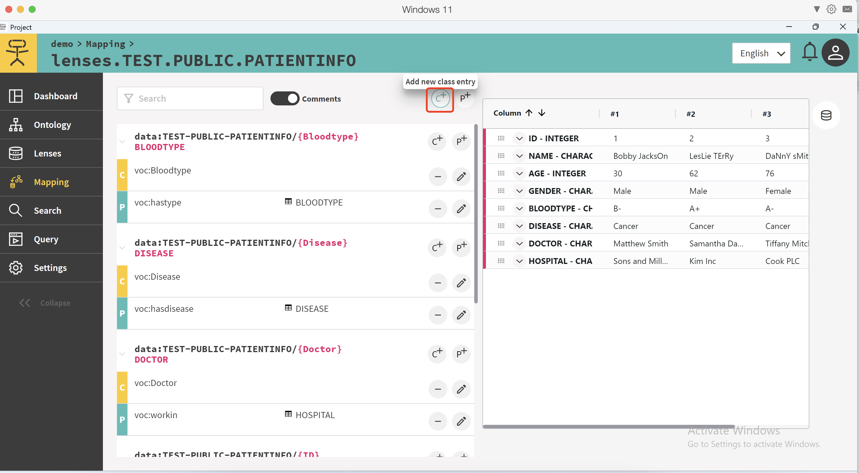

Click “create new template”

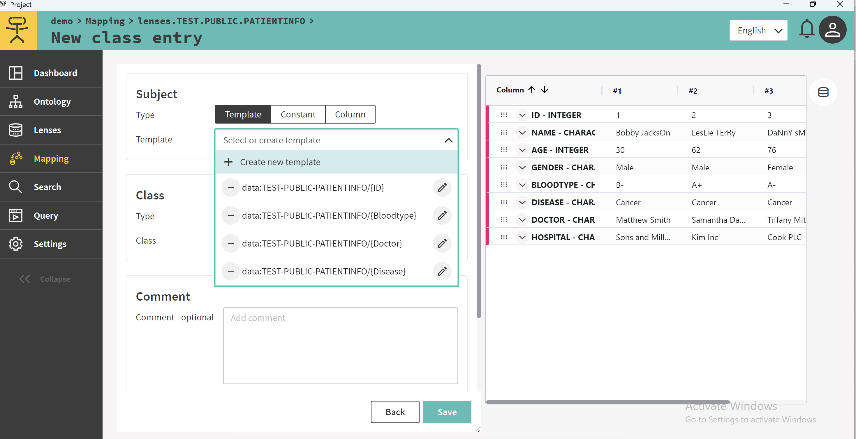 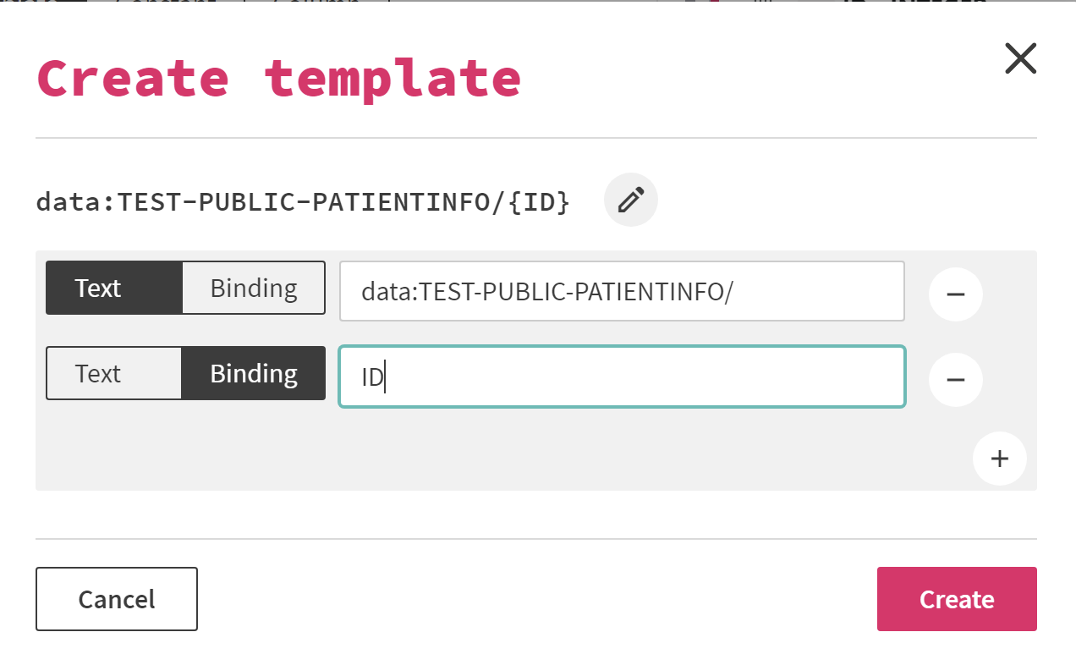

Then click “P+”

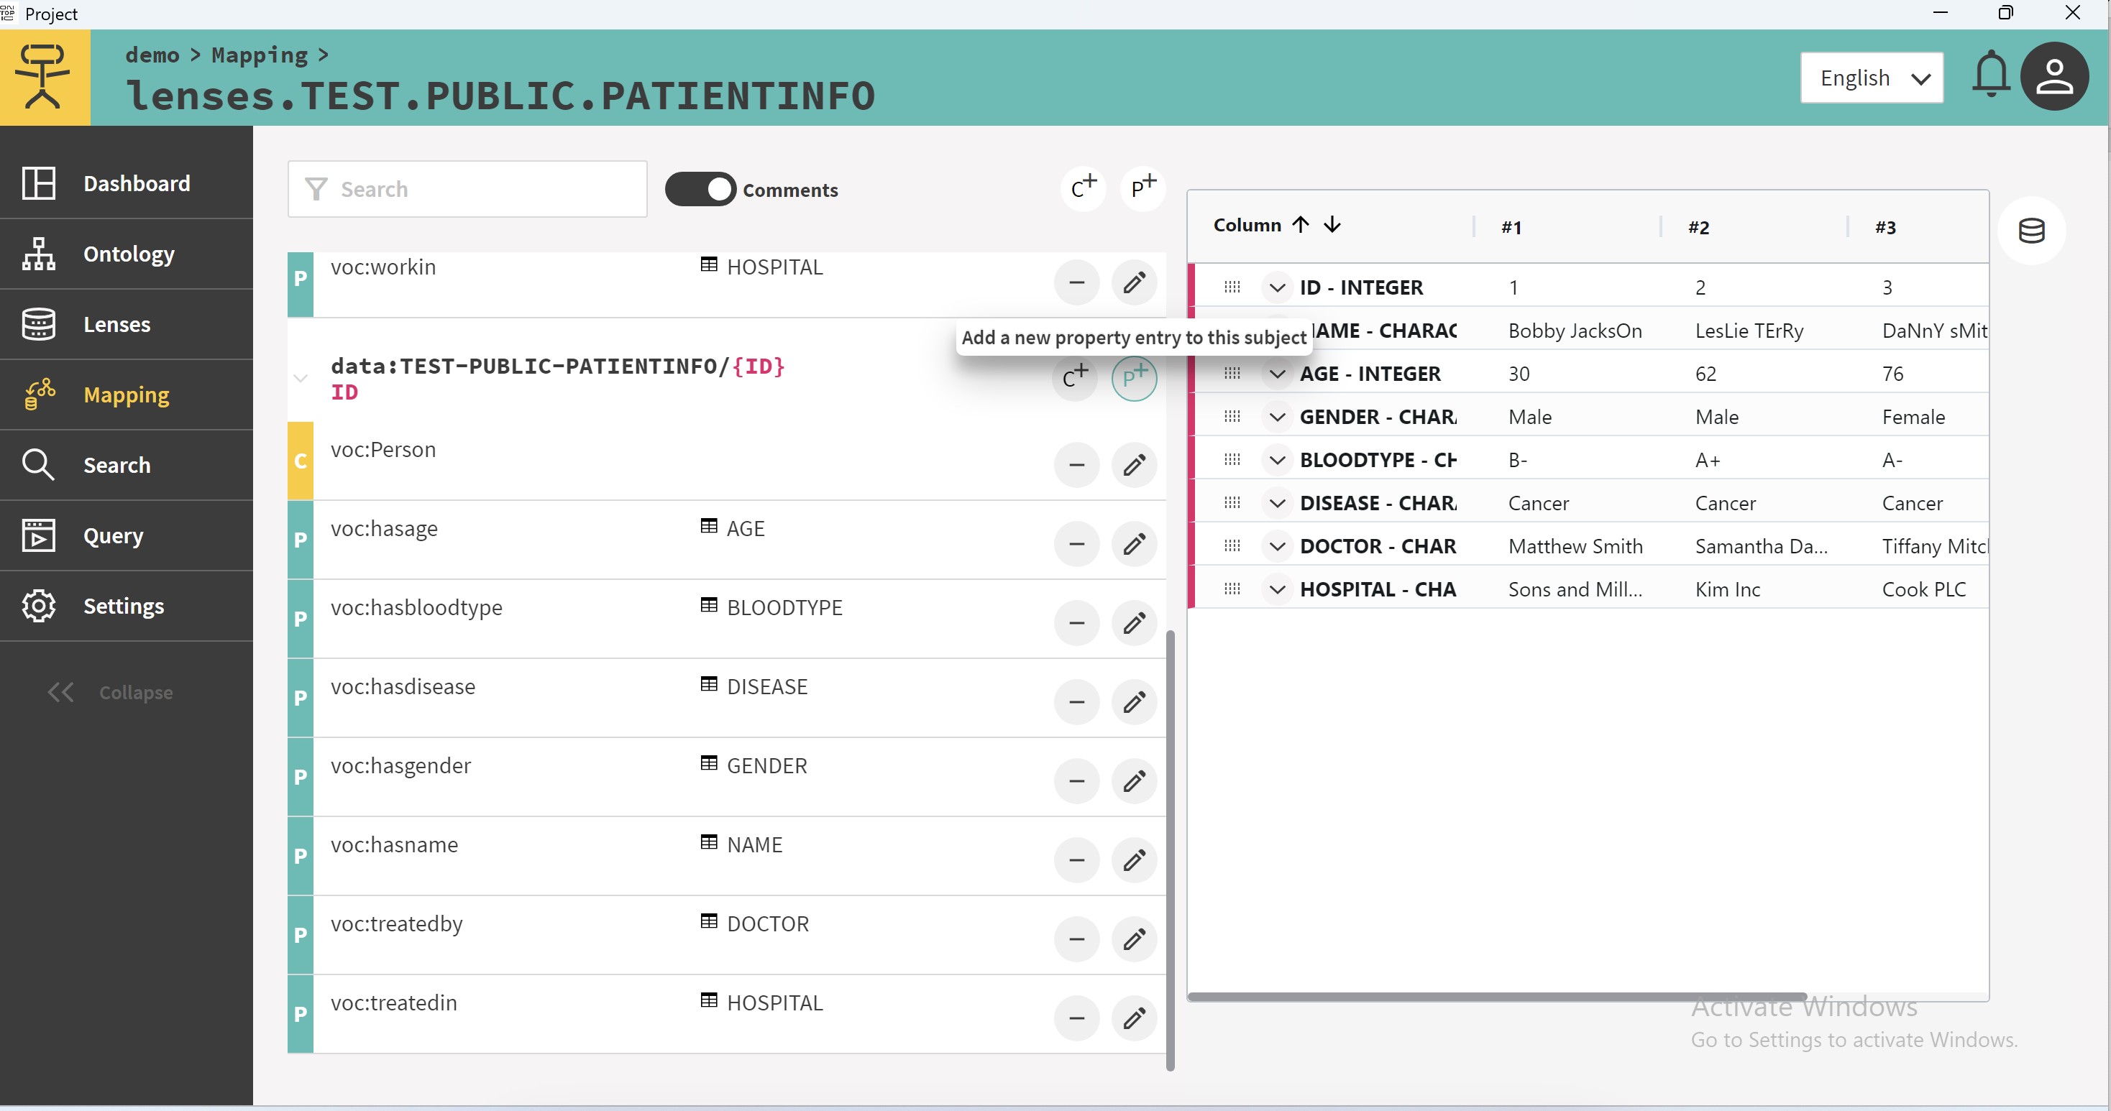

Then, I first create class by selecting the class “Person” in the ontology.

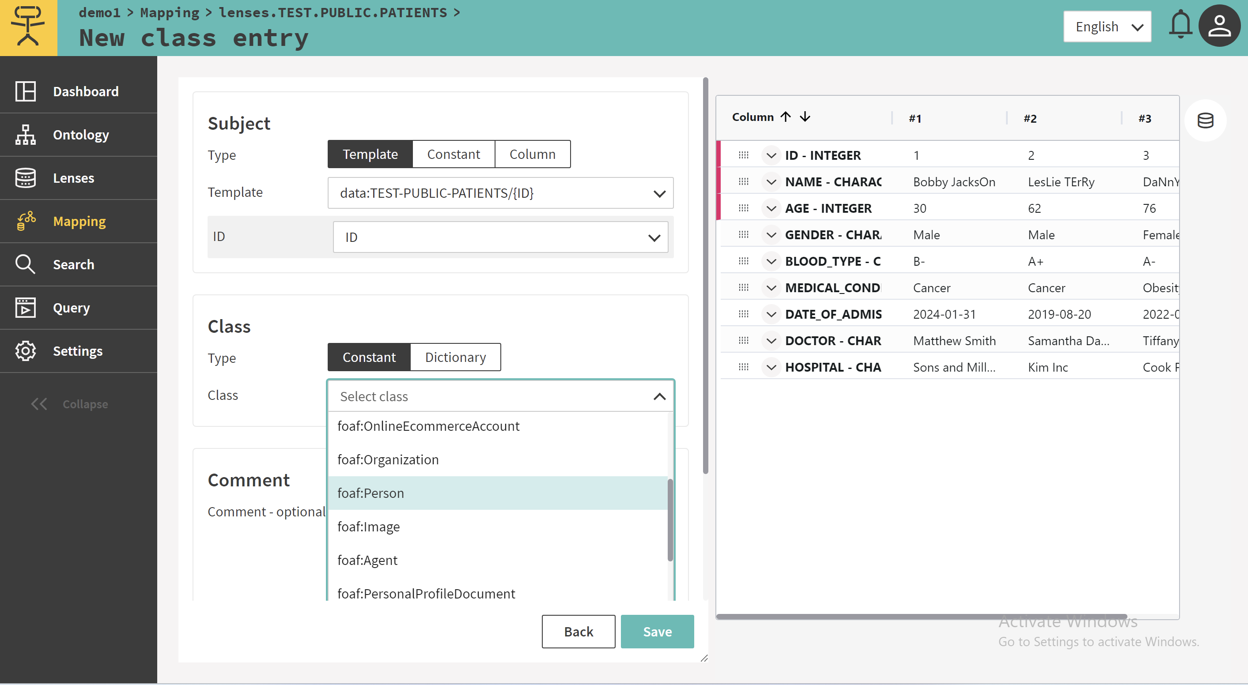

Then, I create property by selecting the property “hasname” in the ontology.

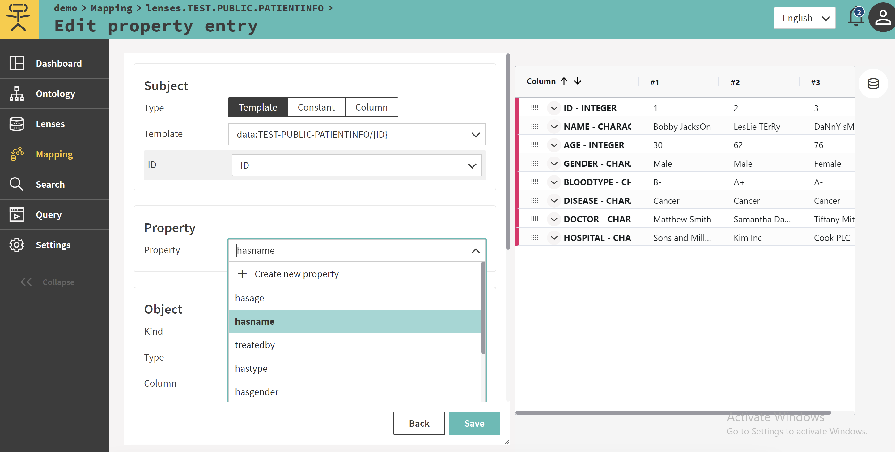Then, I select the column “NAME” in the source data as the object. This step let the Ontopic Studio know where to find the value of name for each person during the RDF transformation.

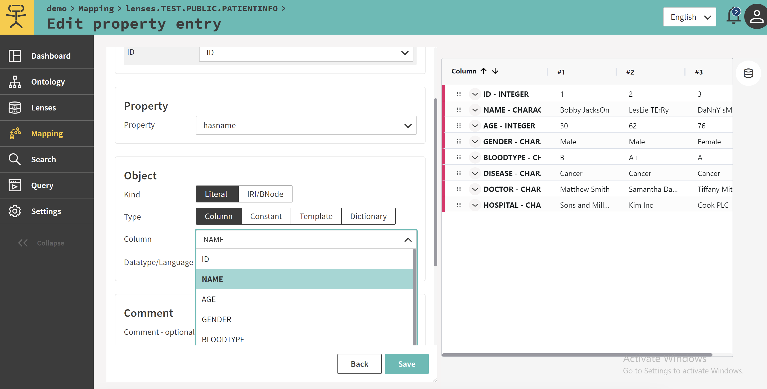

Follow this logic, I map all source data to the ontology.

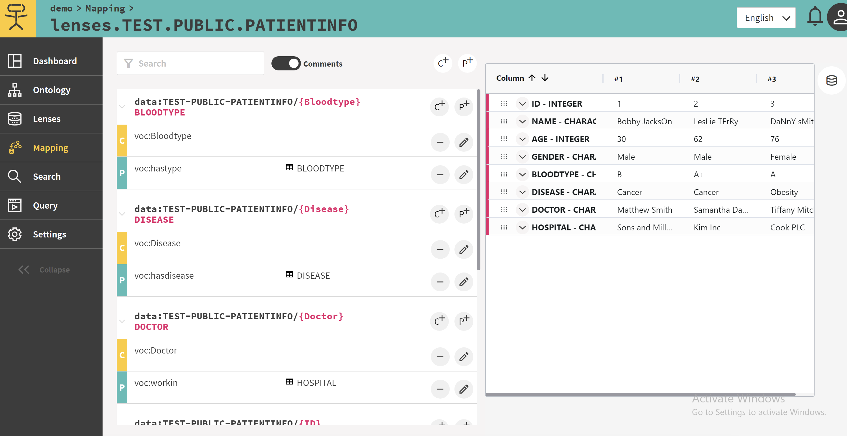 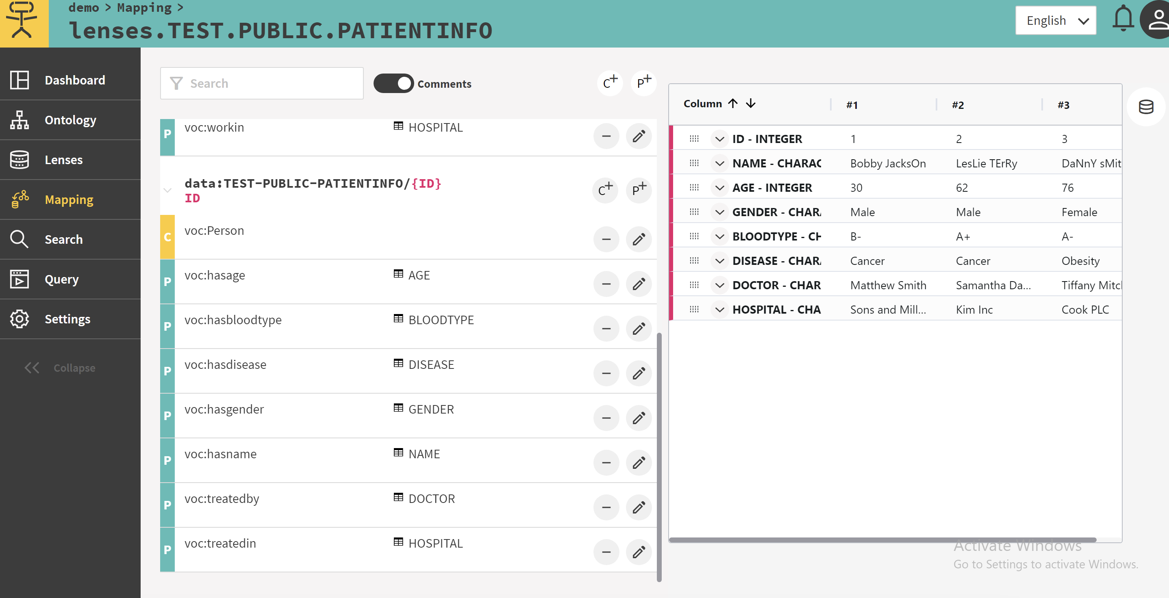

# Materialize

Materialize the source data will transfer source data into RDF format.

## Manual way

This method is simple and only requires clicking a button. However, this method requires manual operation.

Back to the “dashboard” tab after previous steps.

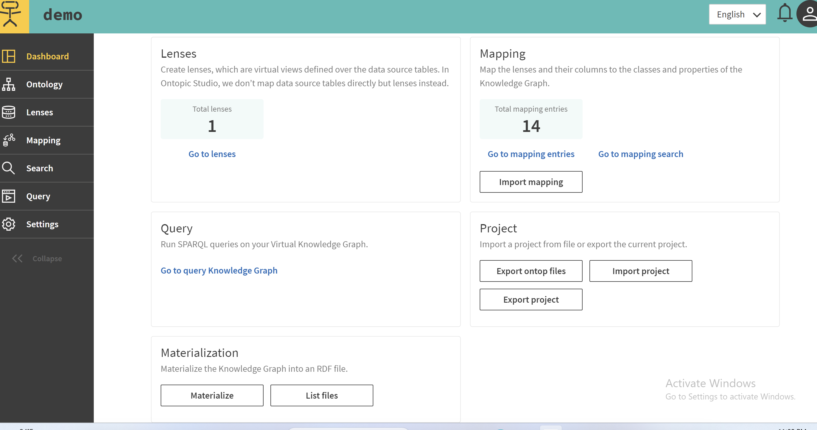

Click “Materialize”.

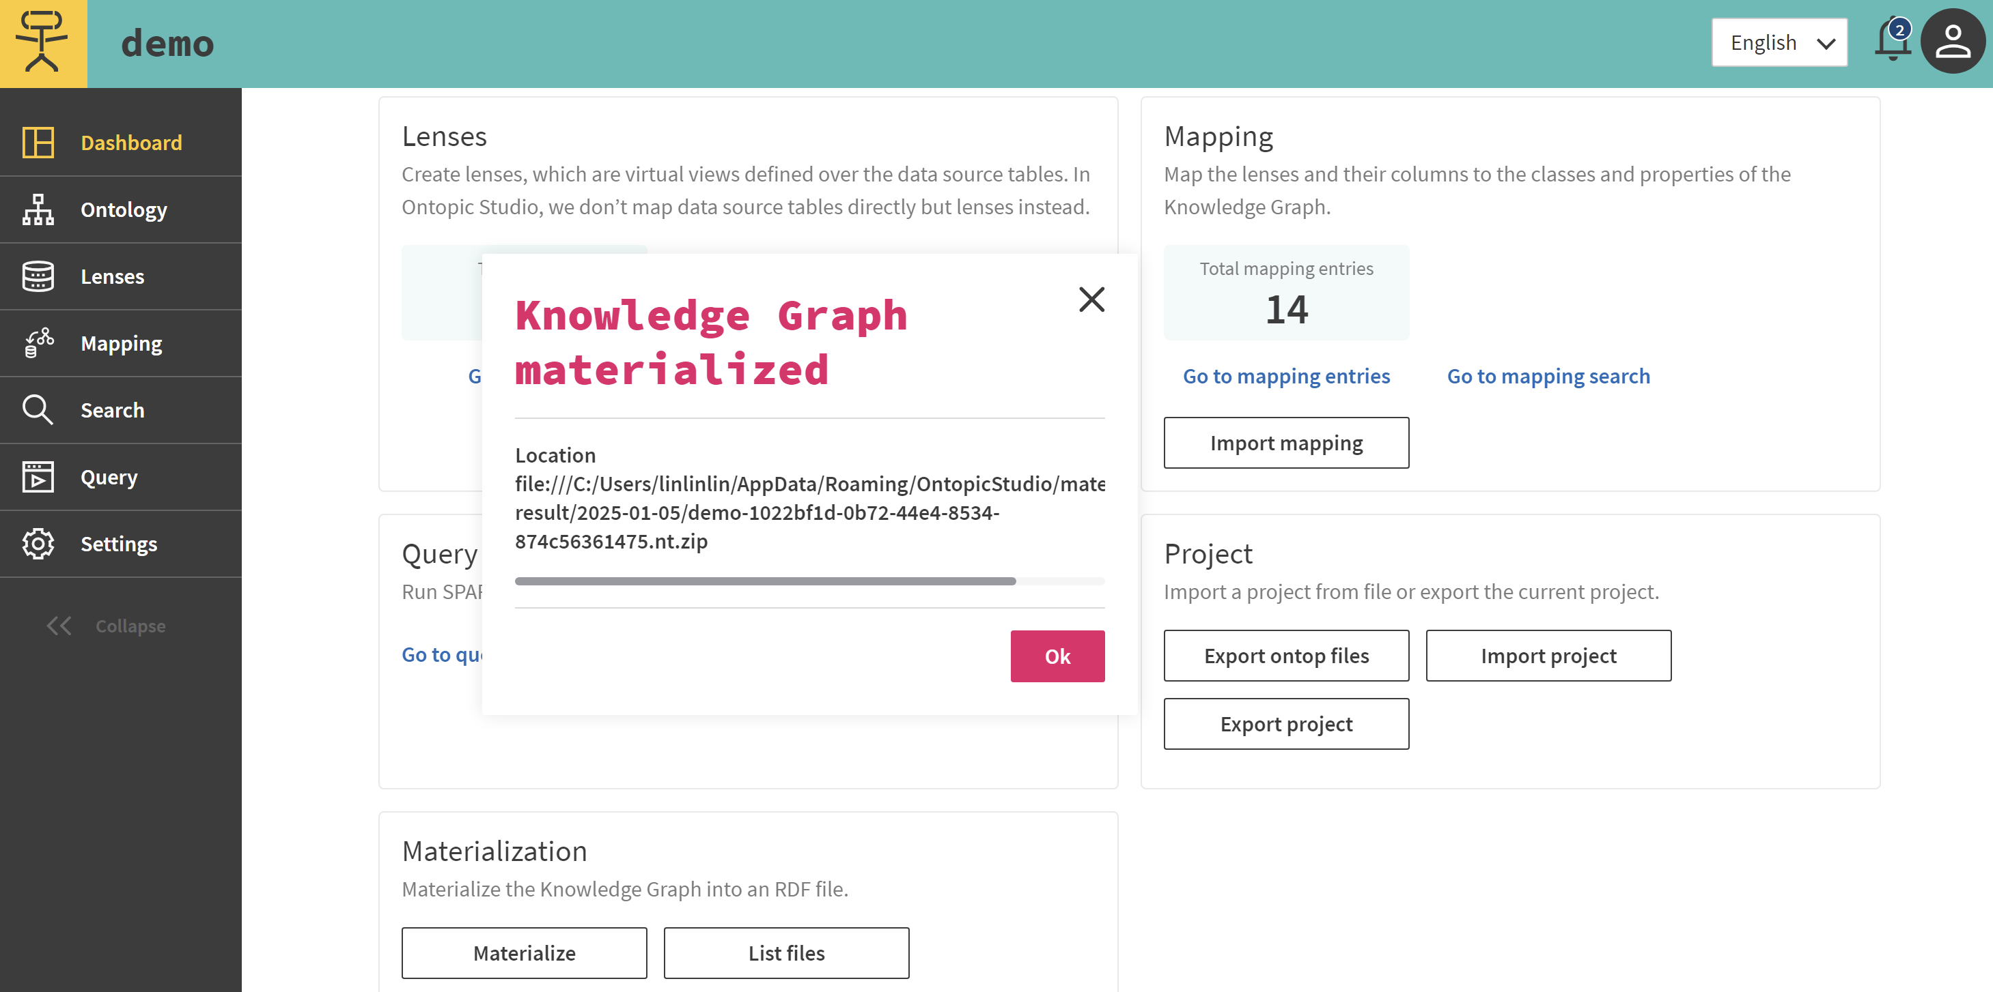

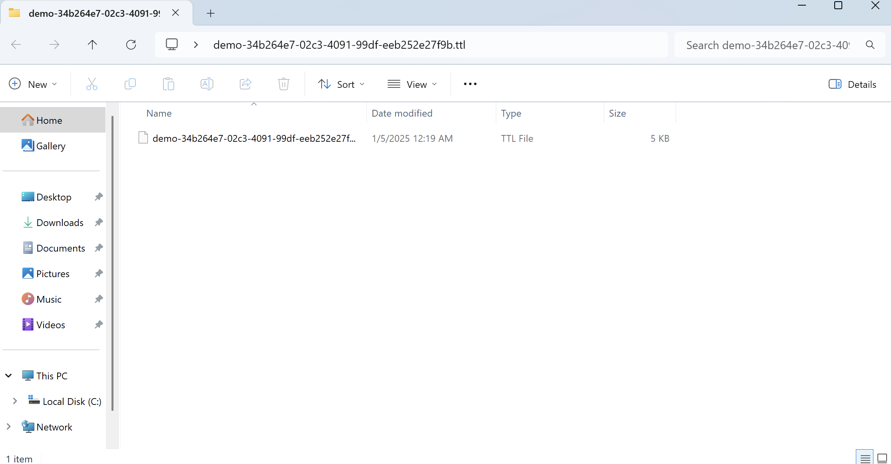 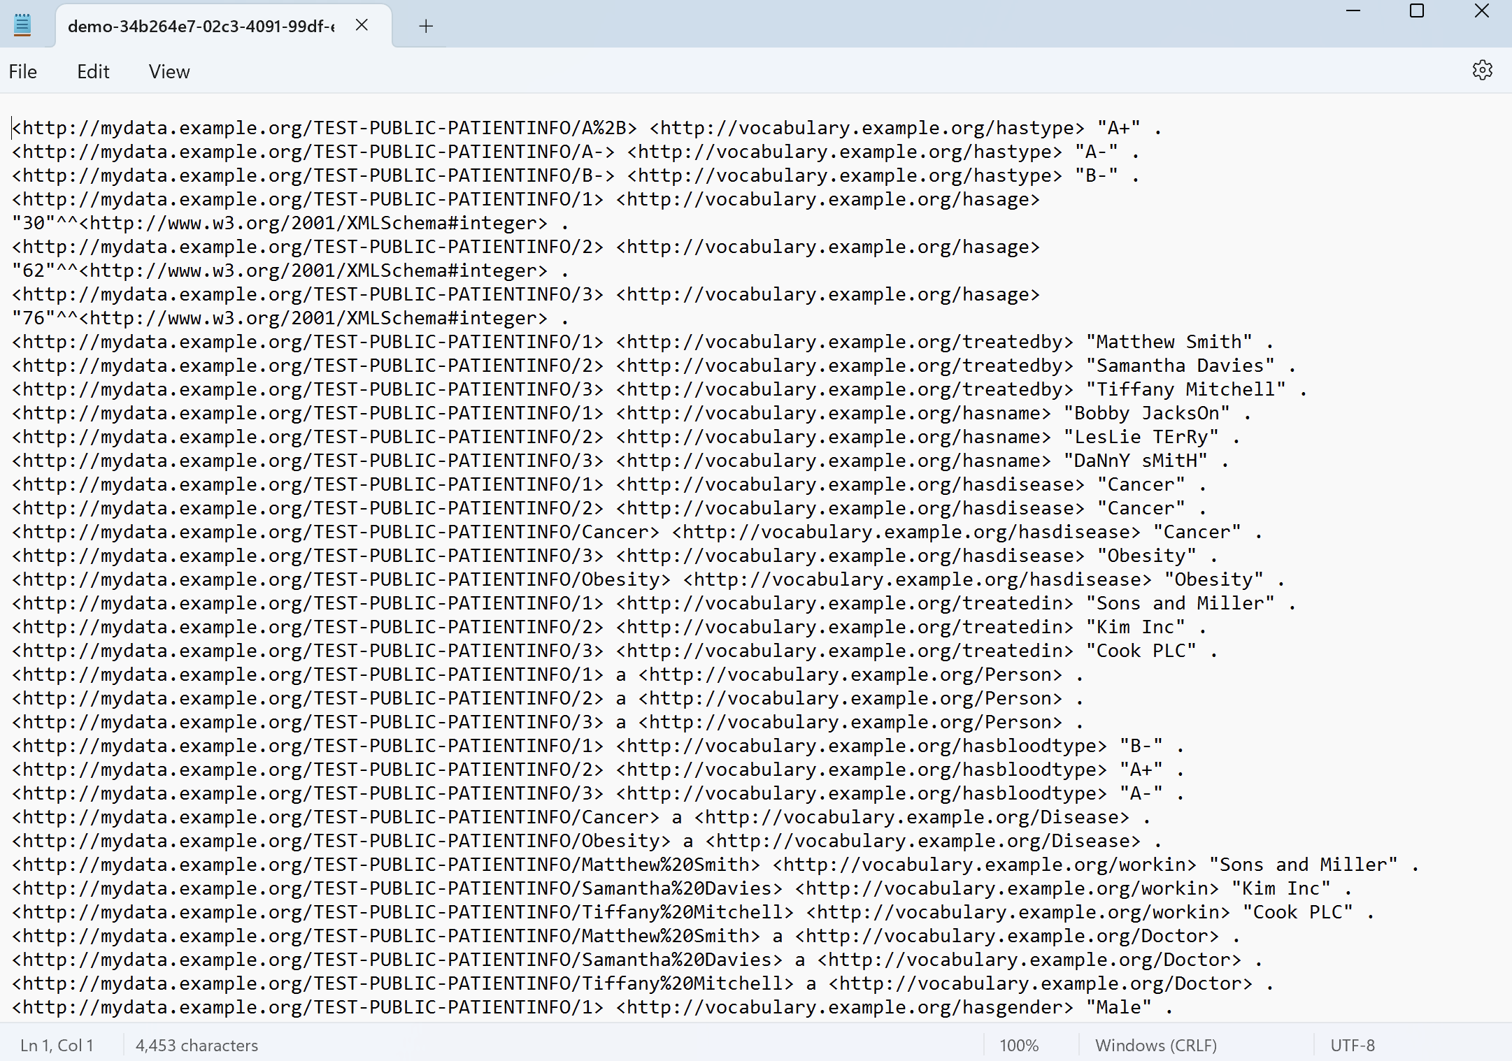

## Automatic way

Users can use Ontop CLI-materialize to achieve the aumation. Ontop itself does not have a complete graphical interface tool and mainly relies on the command line (CLI) and configuration files for operation.

Ontop can be found here

<https://sourceforge.net/projects/ontop4obda/files/>

### Set path

In this Example, my installation file path is"C:\ontop\ontop-cli-5.2.1"

So I set this as path.

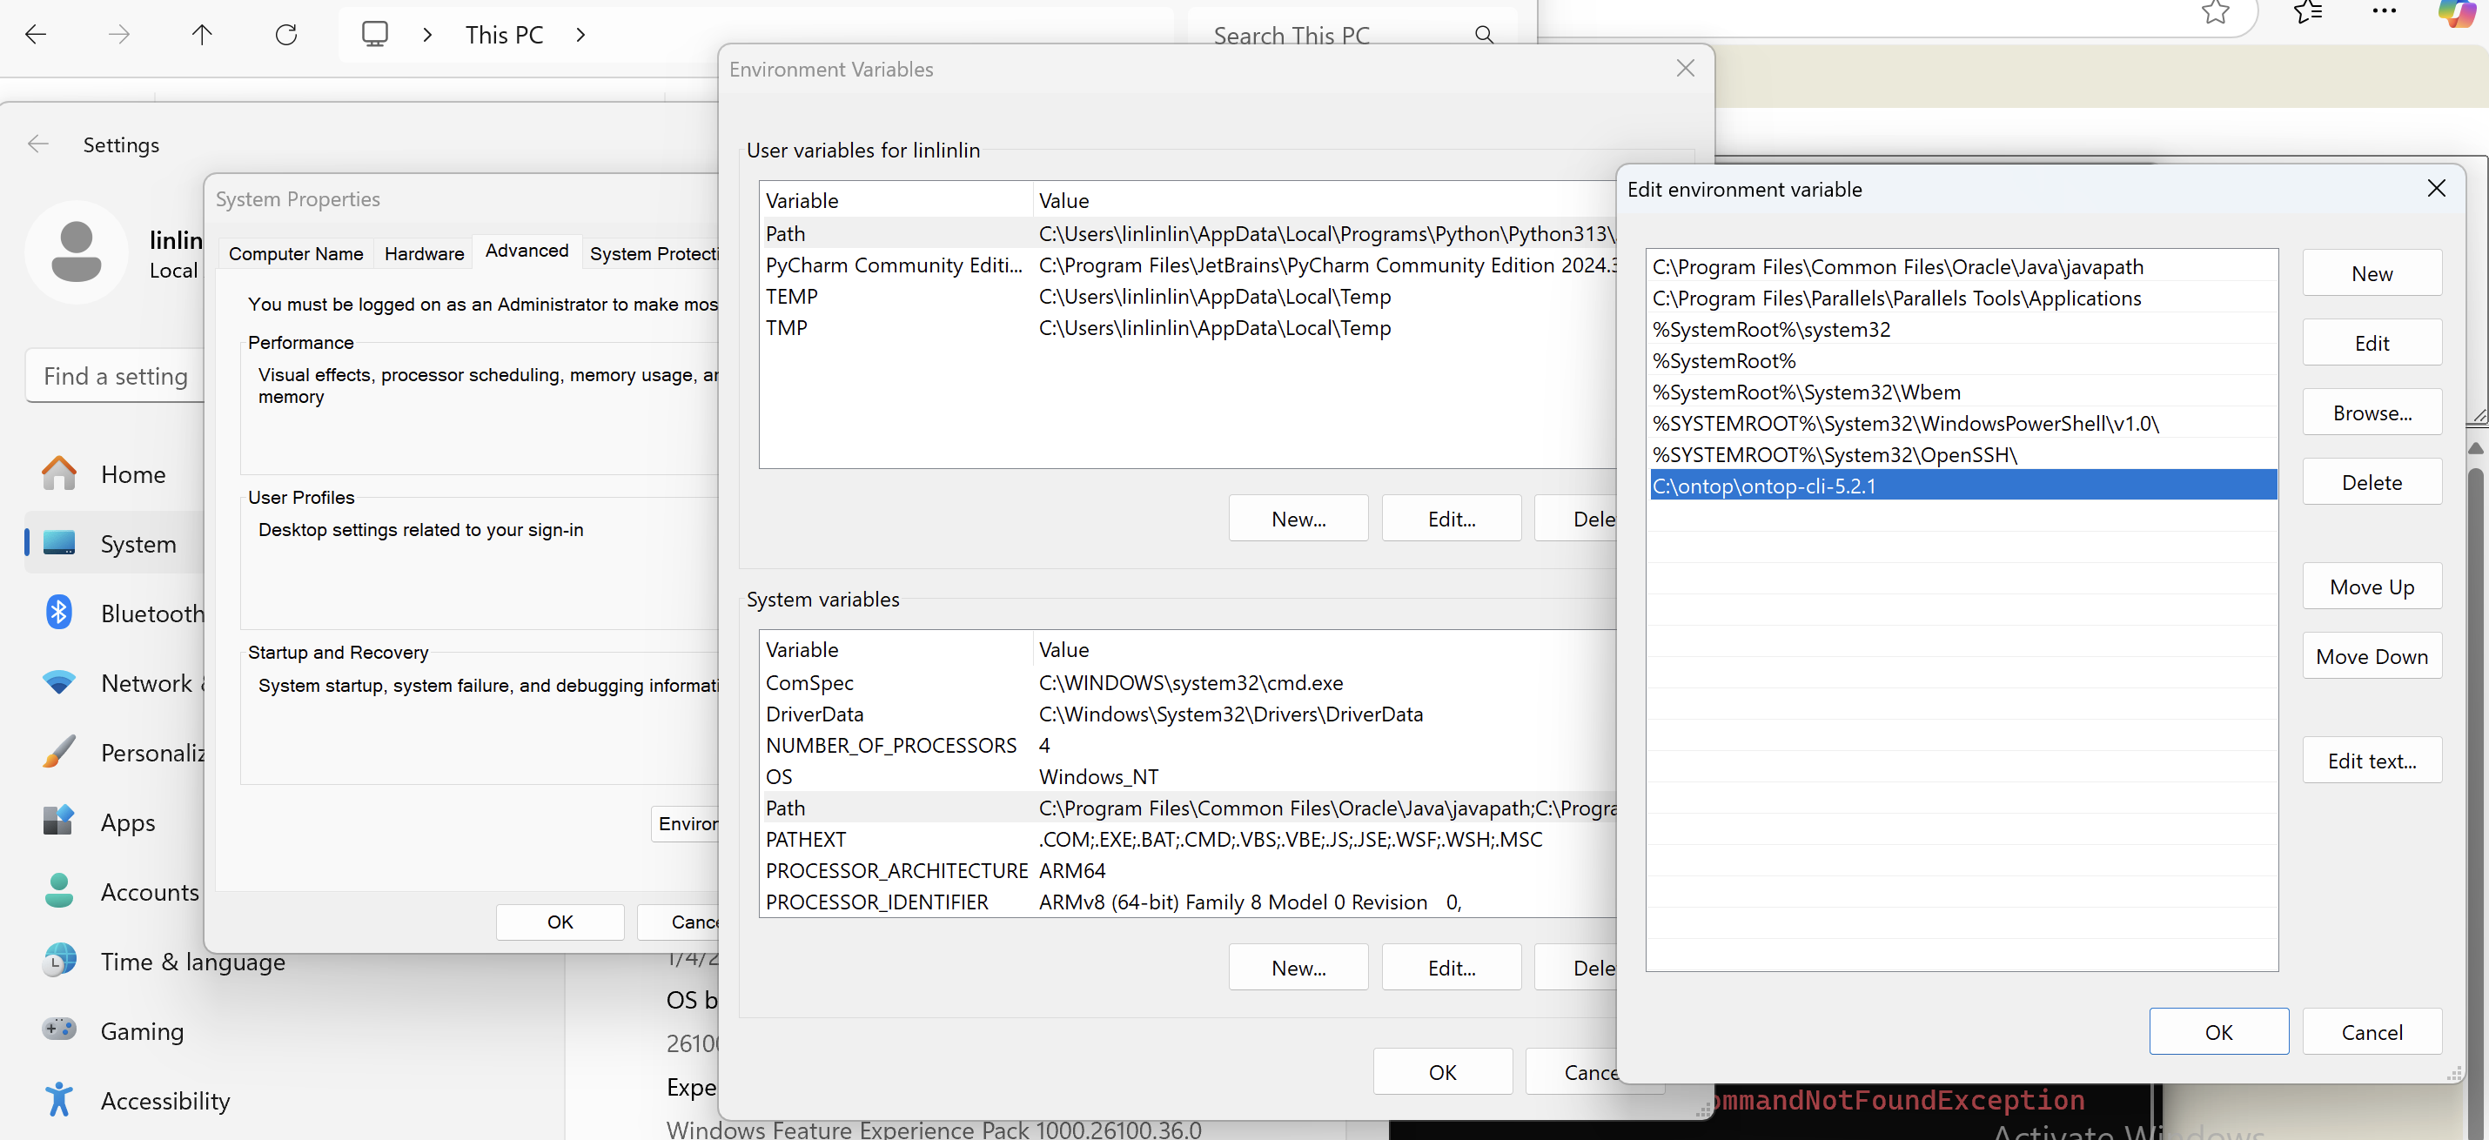

Then, test whether it is correct use command “ontop” in Powershell (do not close the command prompt).

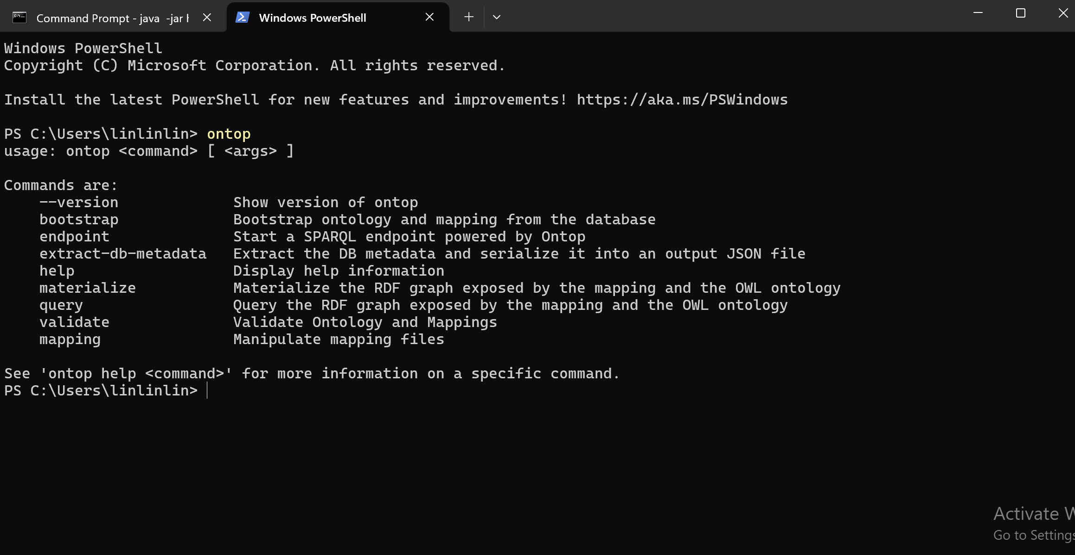

### Create Ontop.properties

In the root directory of the ontop installation file, create a new file “ontop.properties”. Ensure the type is “properties file”.

In this file, write information:

“jdbc.driver=org.h2.Driver

jdbc.url=jdbc:h2:tcp://localhost:8083/~/test

jdbc.user=sa

jdbc.password=”

These information are the same with the information when log in H2 database.

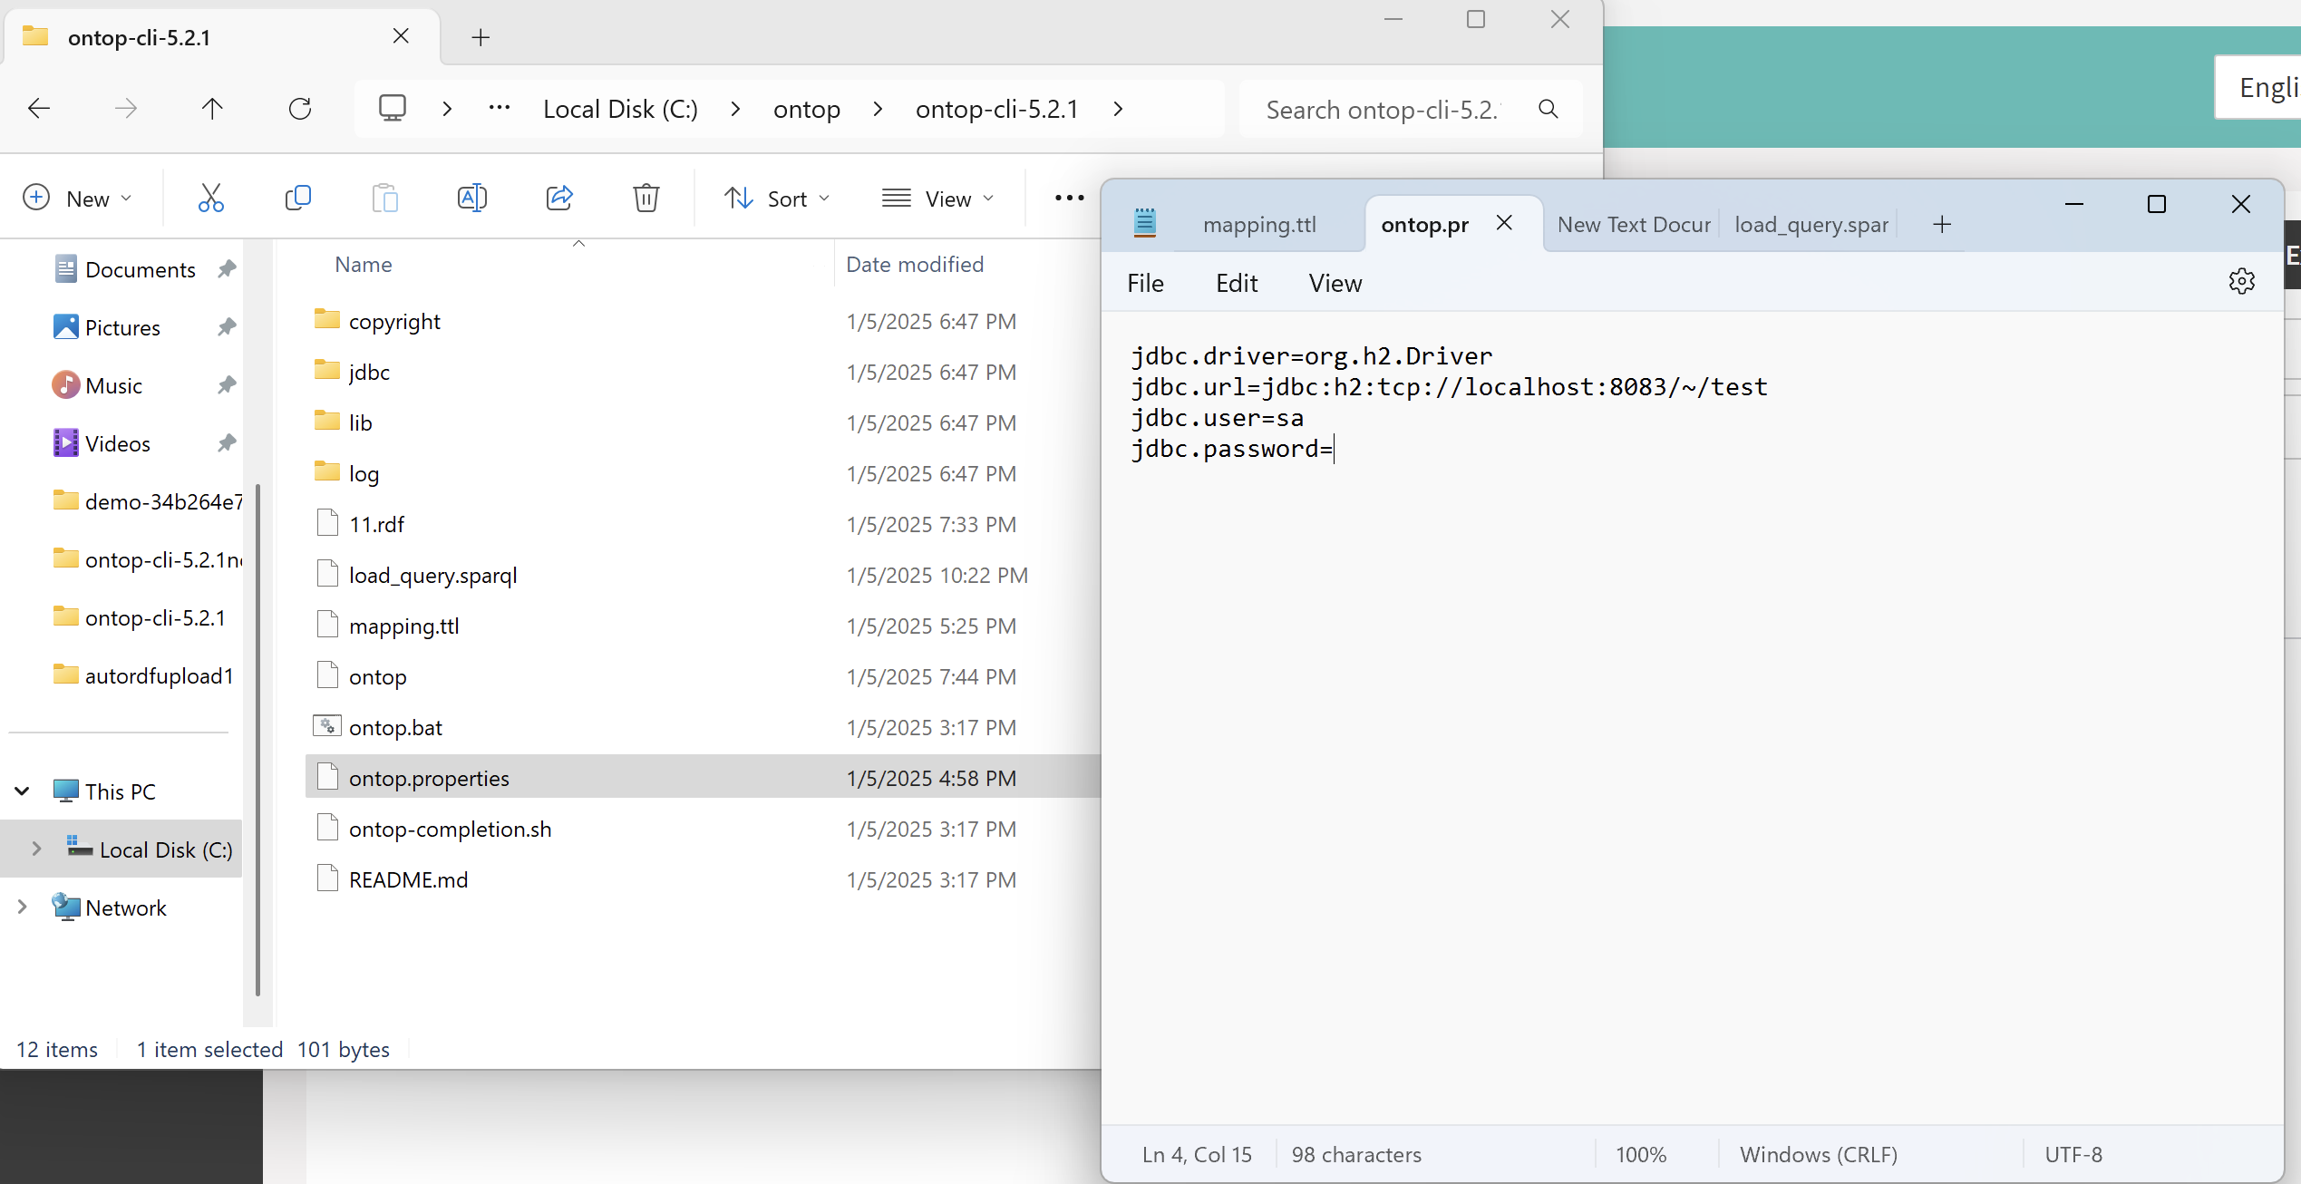

### Connect Ontop and database

Still keep the command prompt, execute command in Powershell.

First enter the file, in this example,

“Command: cd C:\ontop\ontop-cli-5.2.1”

Then, under this file, use command

ontop.bat extract-db-metadata -p "ontop.properties"

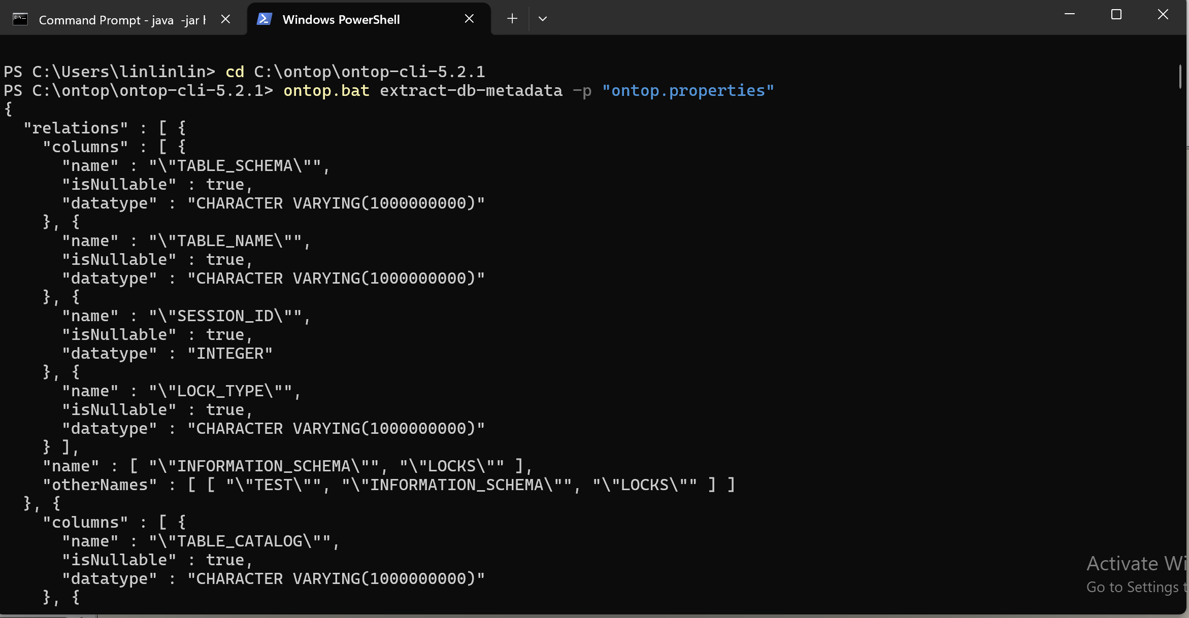

### Download mapping rules file

To achieve materialization, mapping rules file is required. In this case, I use the Ontopic Studio to set the mapping rules in a graphical way. So, I download mapping file from Ontopic Studio. Otherwise, without Ontopic Studio, users need to write the mapping rules manually.

Click “Export mapping”, it can download the mapping rules file.

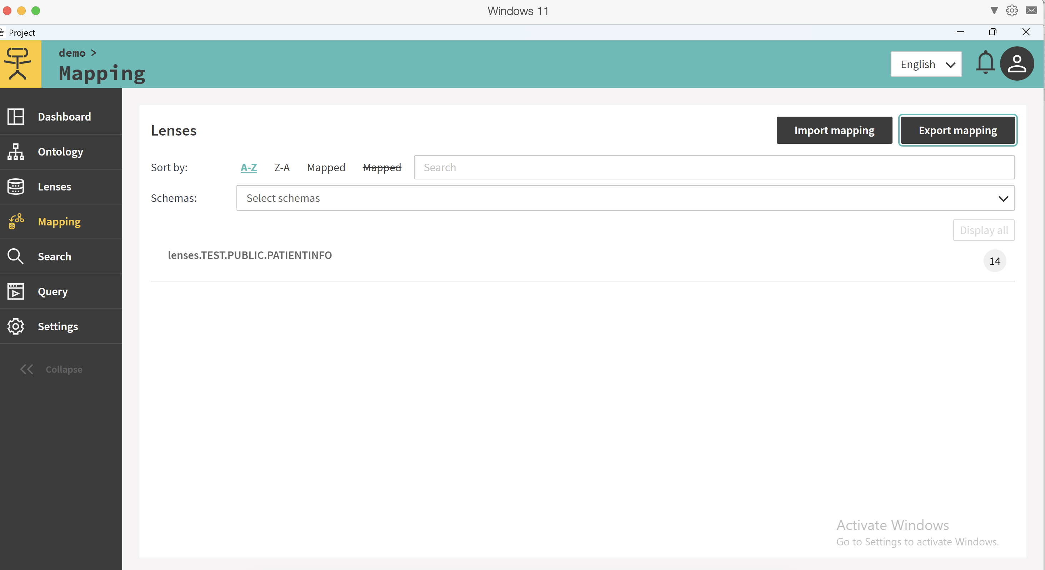

Put the downloaded mapping file (in this example, mapping.ttl) into the unzipped file of the ontop installation package, and make sure that ontop.properties and this file are both in the root directory of the unzipped file of the ontop installation package.

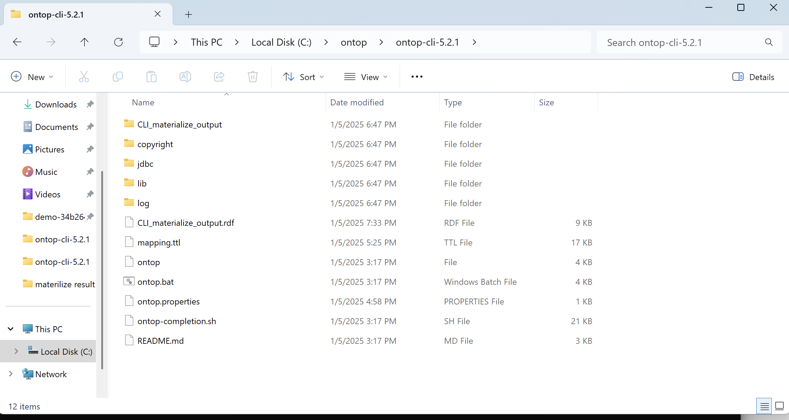

### Materialize

Still keep the command prompt, execute command in Powershell.

First enter the file, in this example,

Command: cd C:\ontop\ontop-cli-5.2.1

Then, under this file, use command

Command: ontop materialize -m "mapping.ttl" -o "CLI_materialize_output" -p "ontop.properties"

* ontop materialize: This is a command in the Ontop command line interface (CLI) that performs a data materialization operation. The materialization process converts the data in the database into RDF format data according to the mapping rules.
* The -m parameter is followed by the path of the mapping file. In this example, it is "mapping.ttl"
* The -o parameter specifies the output file of the materialization operation. In this example, I use “CLI_materialize_output” as the file name of the output. Users can give another name. When you use the same name and execute this command many times, the output file will be automatically replaced with the new one. Multiple output files will only be retained if you set a different output file name each time you run the program.
* The -p parameter specifies a configuration file, which contains settings related to database connection, such as database URL, username, password, etc. In this example, "ontop.properties" is a configuration file containing database connection information which has been defined before.

As shown in the picture, I ran it multiple times. The output files I set for the first three times had the same name “CLI_materialize_output”, so there was only the latest version in the folder. The fourth time, I set a different output file name “CLI_materialize_output1”, so there were both historical output files and current output files in the folder.

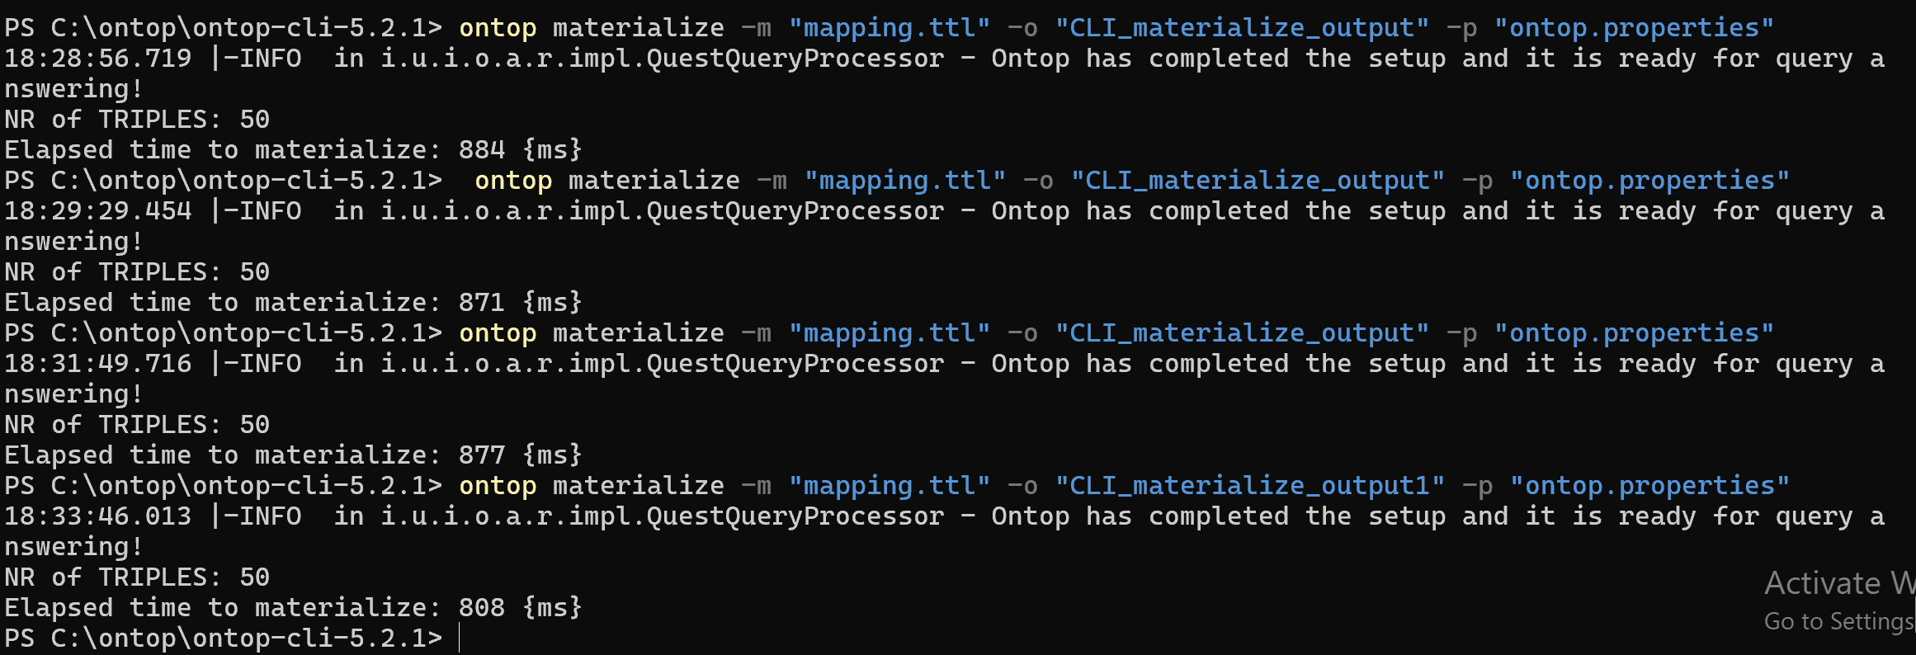

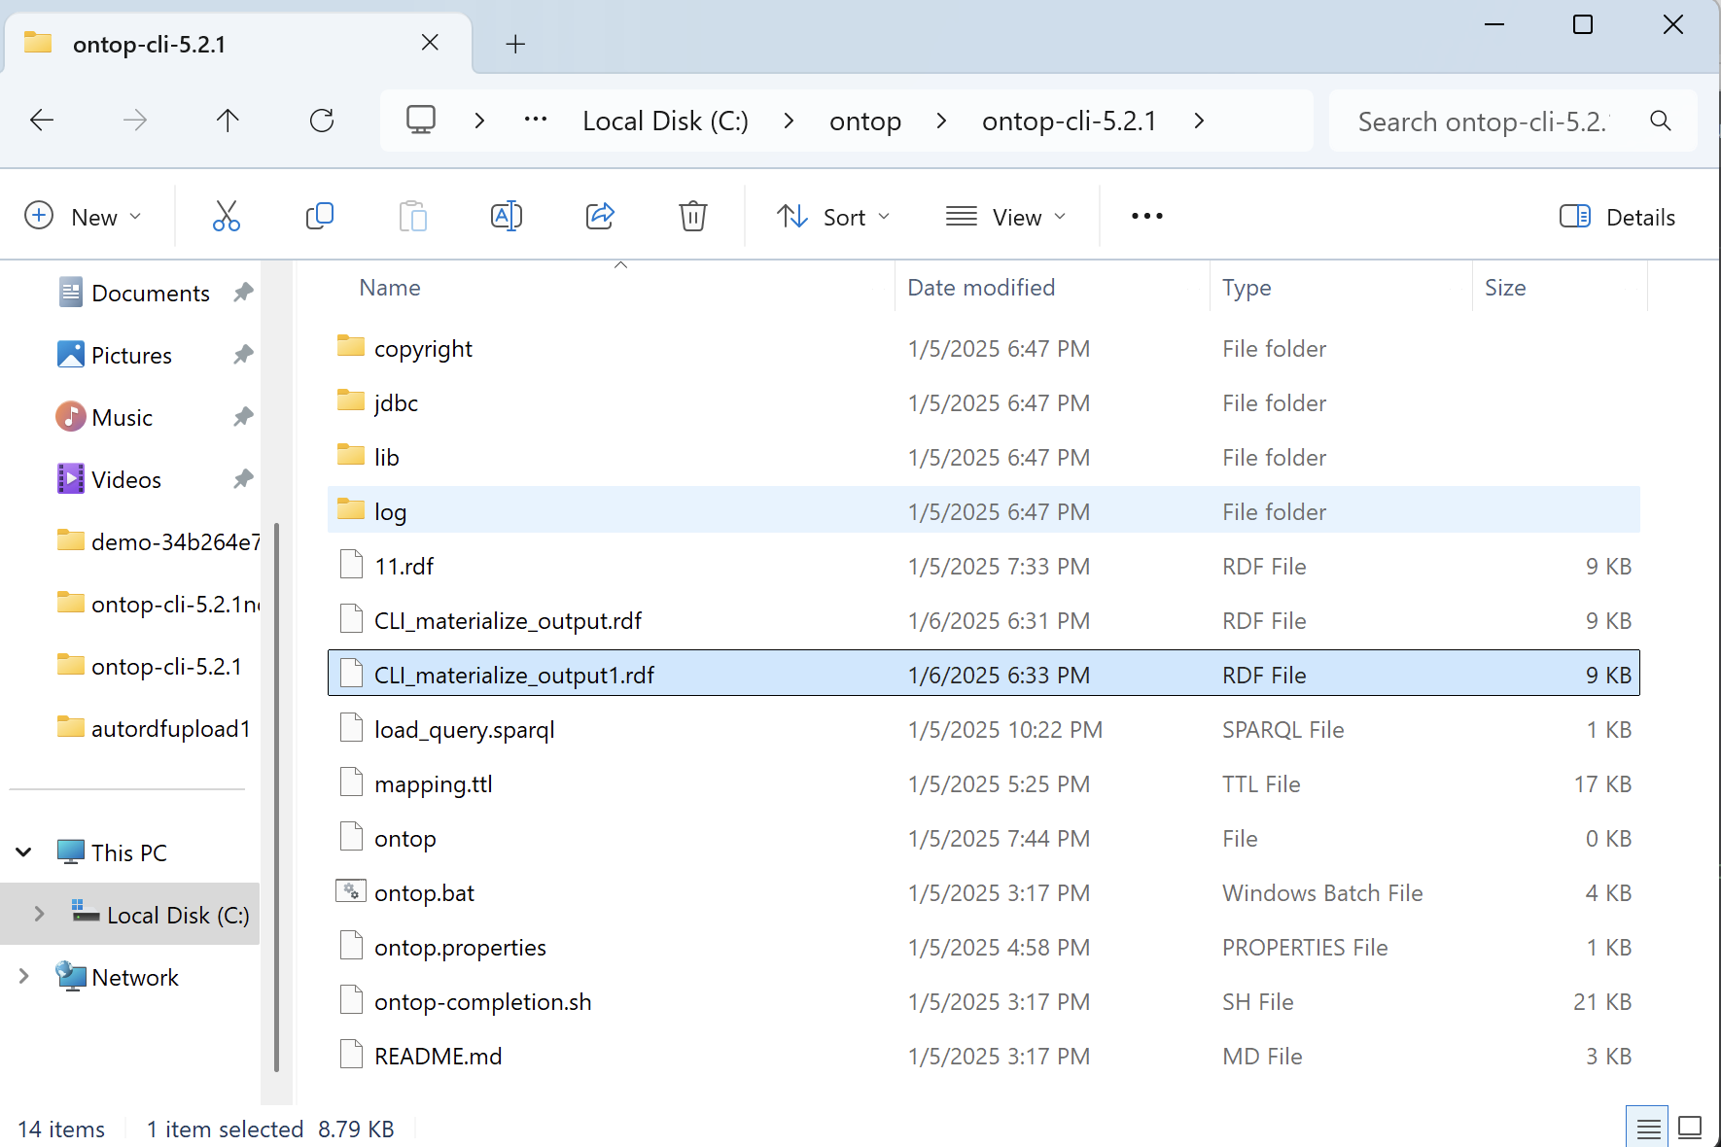

# Upload RDF into triplestore

In this example, I use AllegroGraph, which can be found here:

<https://allegrograph.com/>

## Manual way

Users can upload the RDF file into AllegroGraph manually.

This RDF file could be the one downloaded from Ontopic Studio or the one generated by Ontop CLI-materialize.

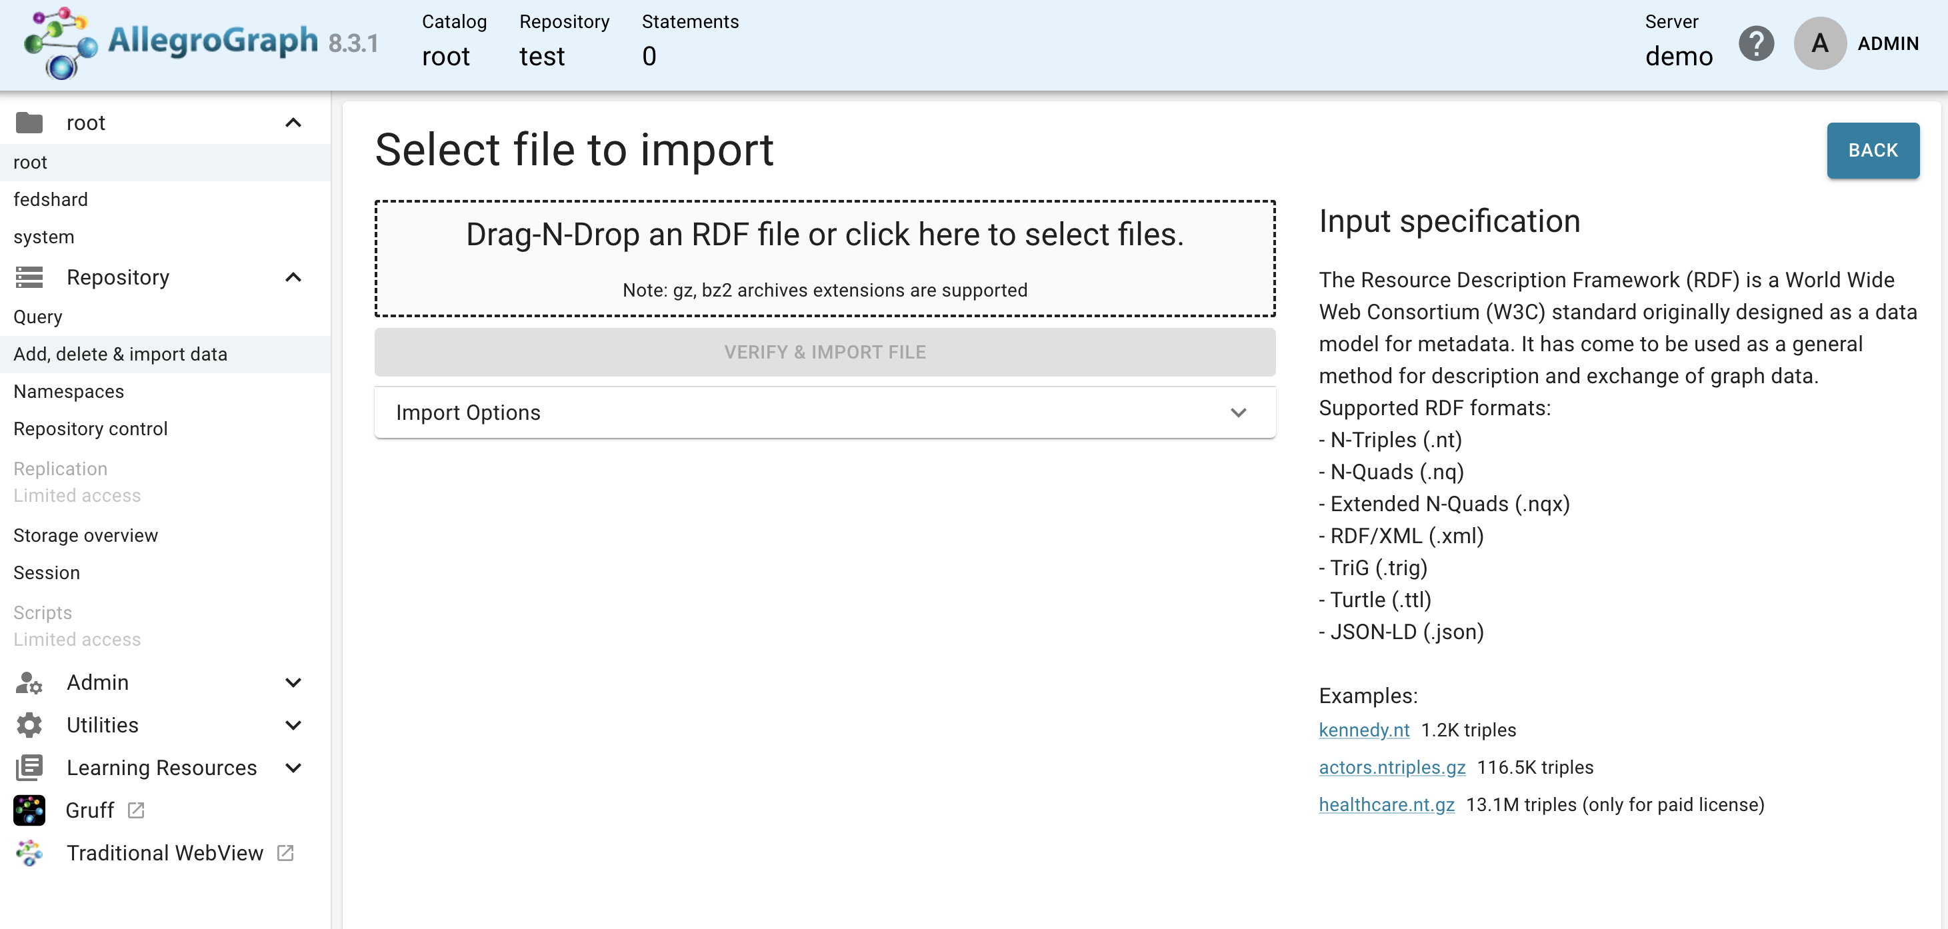Then, in the Gruff,change the view to “Query view”.

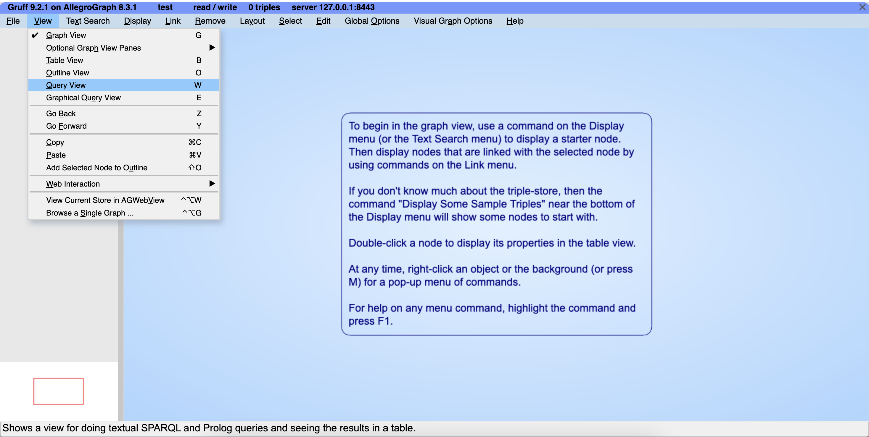

First click “Run Query” and then “Creat Visual Graph”.

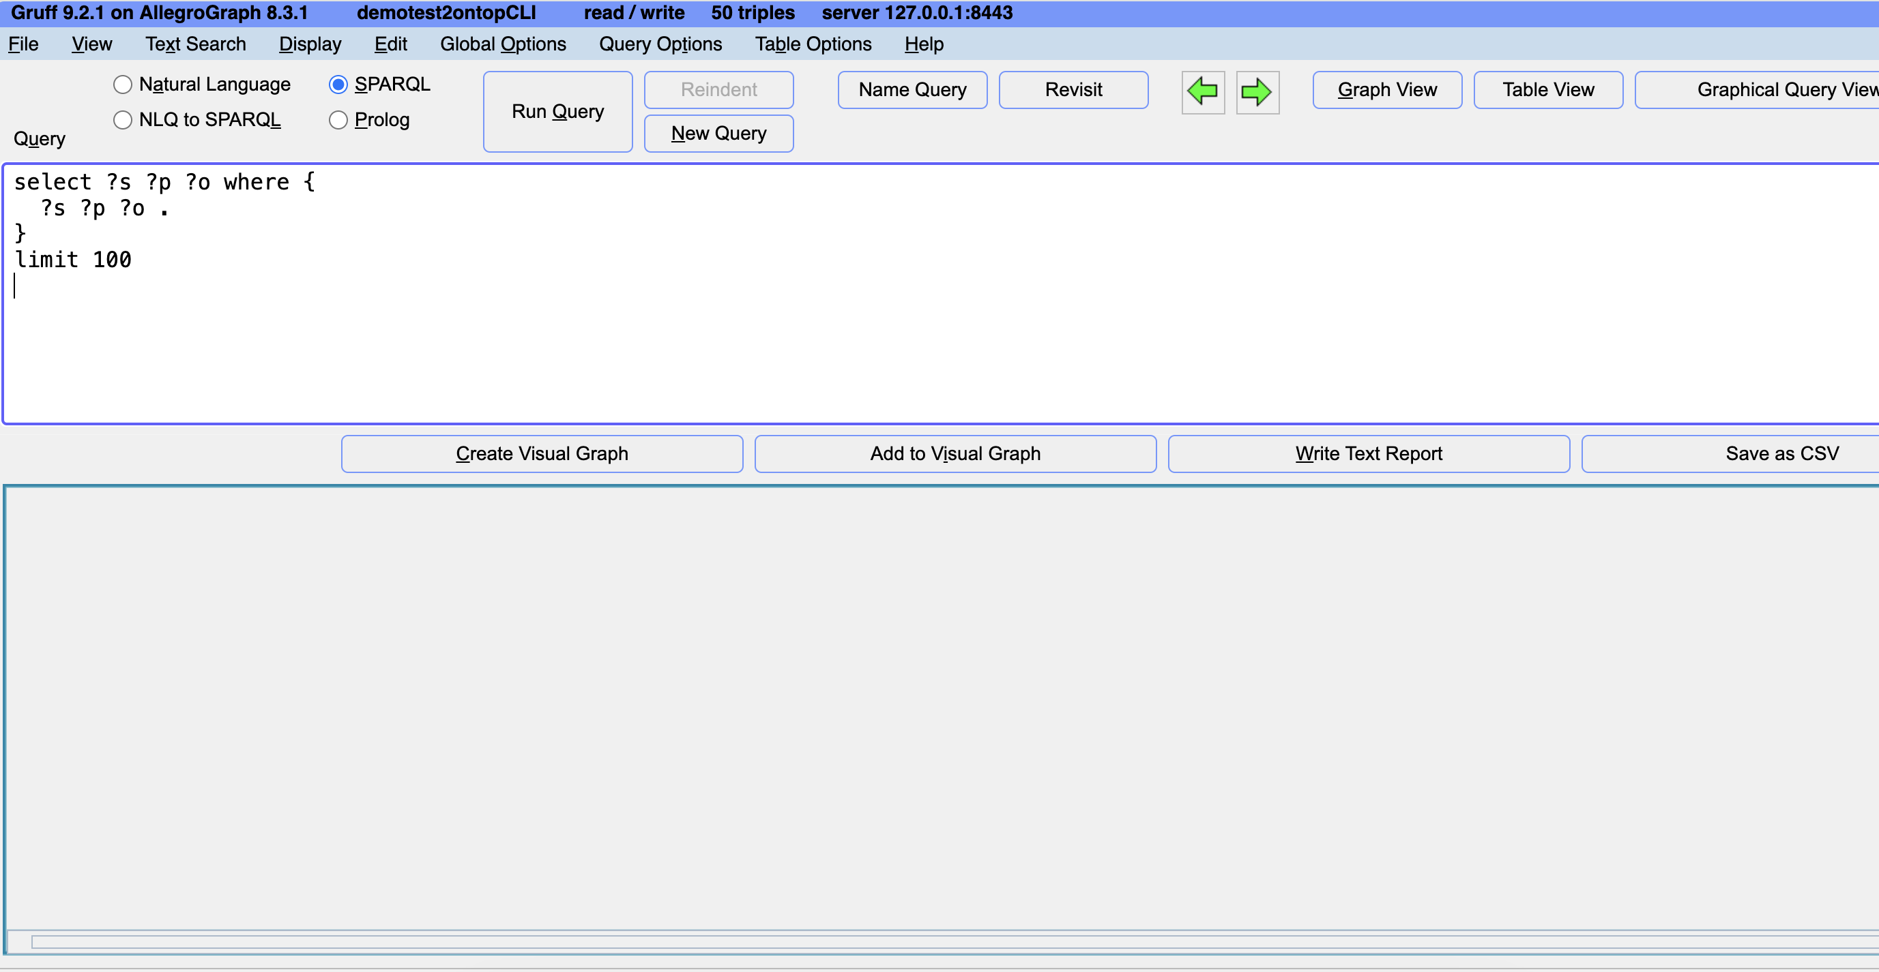

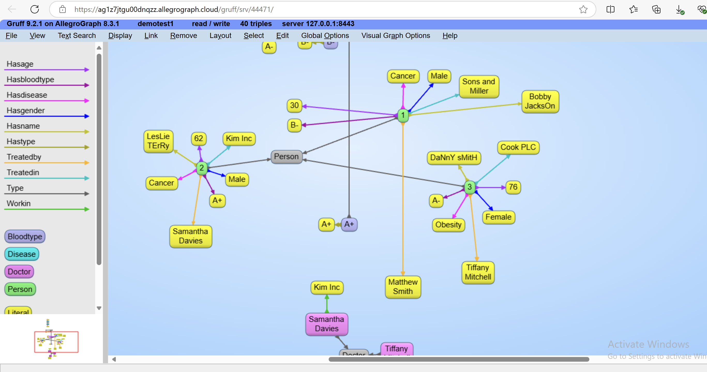

If users would like to query information, users could go back to the query view.

SELECT ?s ?p ?o

WHERE {

?s ?p ?o .

?s ?p "LesLie TErRy" .

}

LIMIT 100

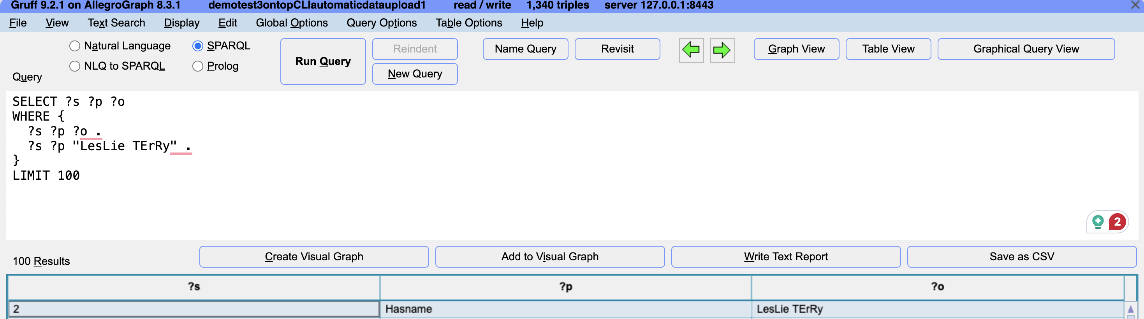

## Automatic data upload

Upload data to AllegroGraph through the REST API via HTTP POST requests, thereby achieving automatic data upload.

I write a python script that does this. In this way, I automatically upload the RDF file generated by Ontop CLI-materialize. This code just implements automatic uploading of RDF to AllegroGraph.

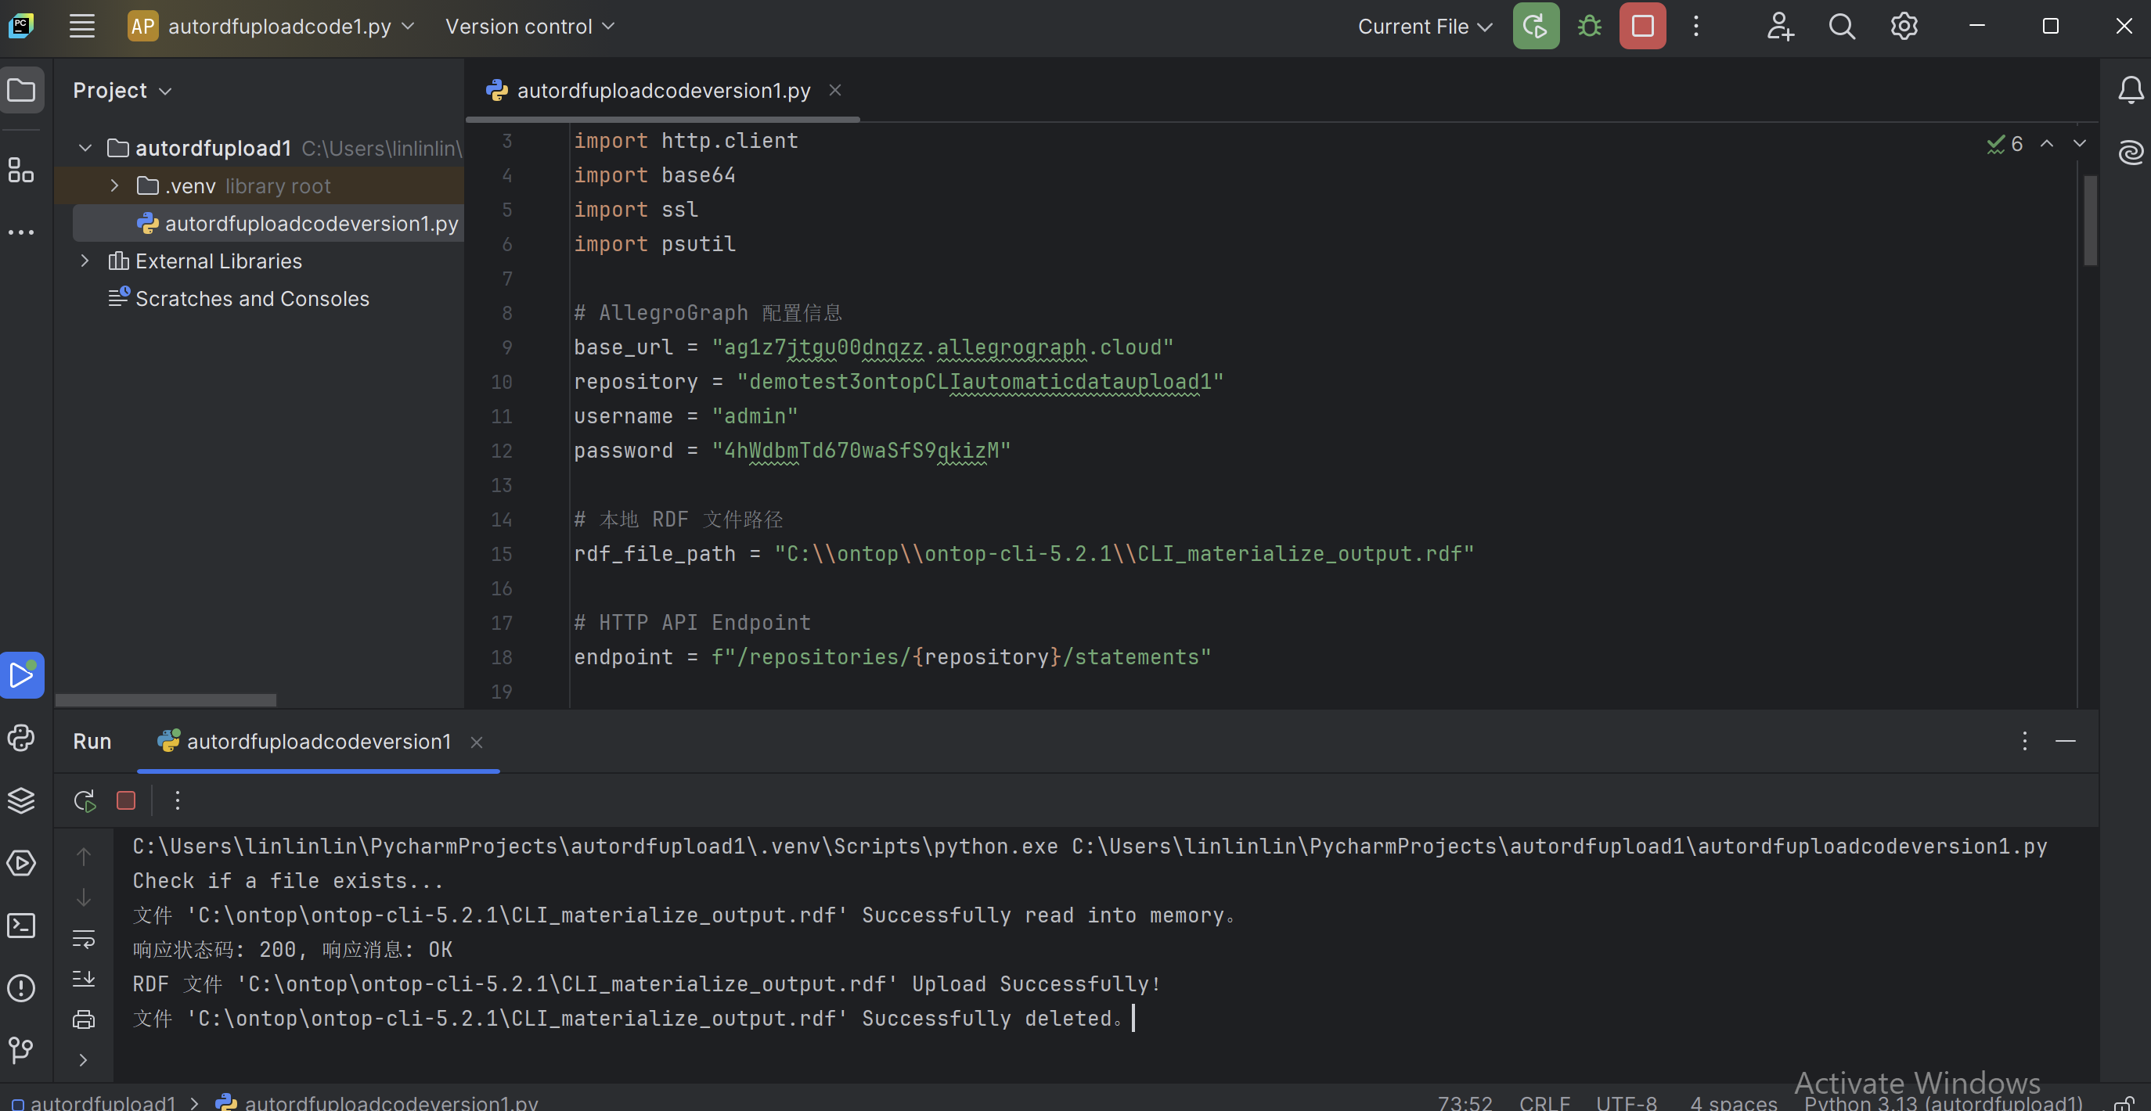

# De novo FAIRification AutoFlow

To fully automate the process without human involvement, I wrote a Python script that integrates Ontop CLI-materialize with code to automatically upload RDF data to the database. This enables users to simply execute the script, which handles the entire workflow of materializing RDF data and uploading it to the database automatically, eliminating the need for manual intervention. And this code implements real-time RDF conversion of incremental data and uploads it to AllegroGraph. This design is more in line with the needs of the legacy system.

## System Settings

### Adjust PowerShell's execution policy

Allow PowerShell to execute scripts: You need to set PowerShell to allow execution of local scripts (including .ps1 scripts) and .bat files. This command allows you to execute local .ps1 scripts (for example, activate.ps1 files to activate virtual environments).

Set-ExecutionPolicy -ExecutionPolicy RemoteSigned -Scope CurrentUser

* RemoteSigned: Allows running local scripts (without signatures), but scripts downloaded from the Internet must be signed. This setting is relatively safe
* CurrentUser: Only affects the PowerShell execution policy of the current user.

Confirm that the changes have taken effect: You can confirm the current execution policy with the following command:

Get-ExecutionPolicy -List

If you see that the policy of CurrentUser is RemoteSigned, it means that it has been successfully modified.

### Activate the virtual environment

After modifying the execution policy, you can try to activate the virtual environment again:

.\.venv\Scripts\activate

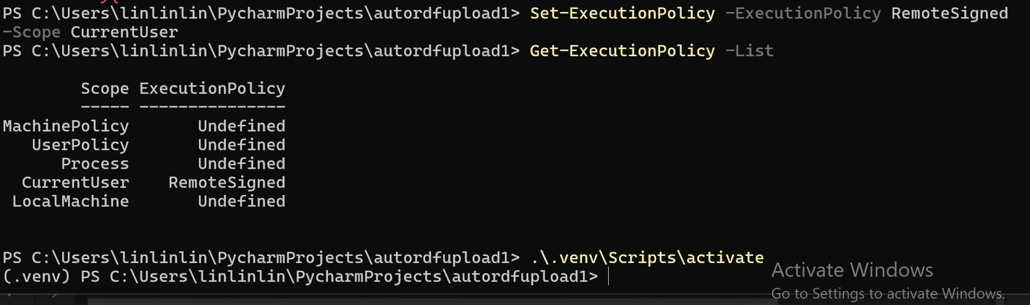

Then activate the virtual environment in PyCharm's terminal

.\.venv\Scripts\activate

### JPype

Install, reinstall or upgrade JPype in PyCharm's terminal

pip install --upgrade --force-reinstall jpype1

Check the JPype path (sometimes JPype is not installed in the correct location, which results in the inability to find the relevant DLL files. You can confirm this by looking at the JPype installation path)

pip show jpype1

### Java Configuration

Check if Java is installed

java -version

Set the Java home system variable

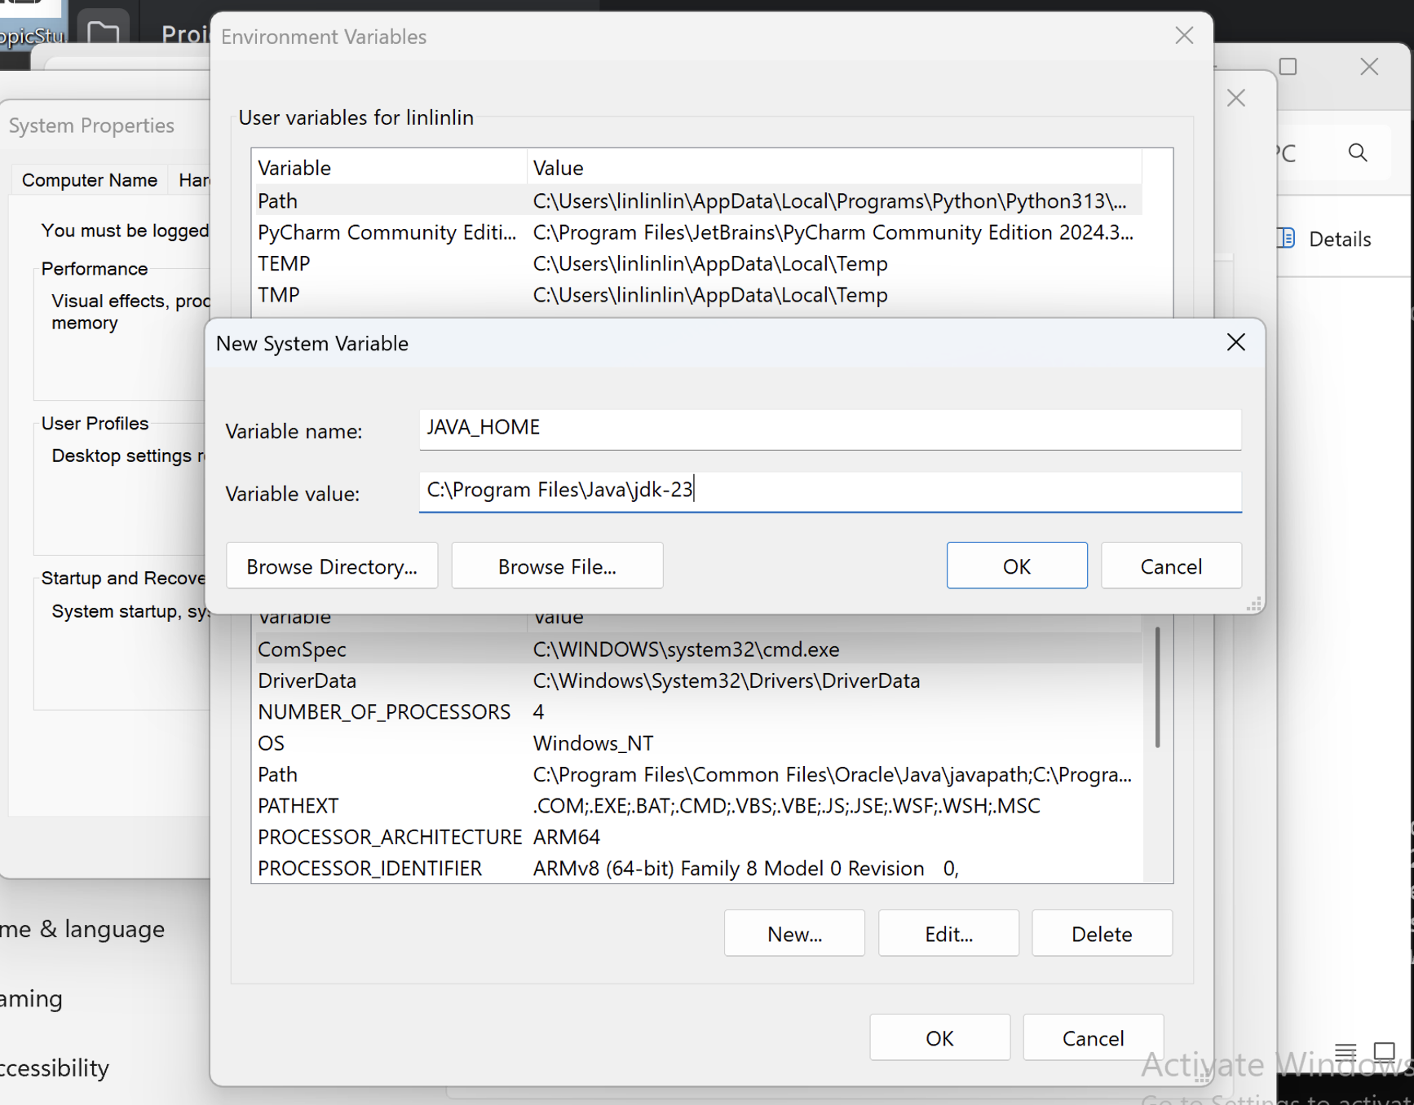

Set the path, and set it first.

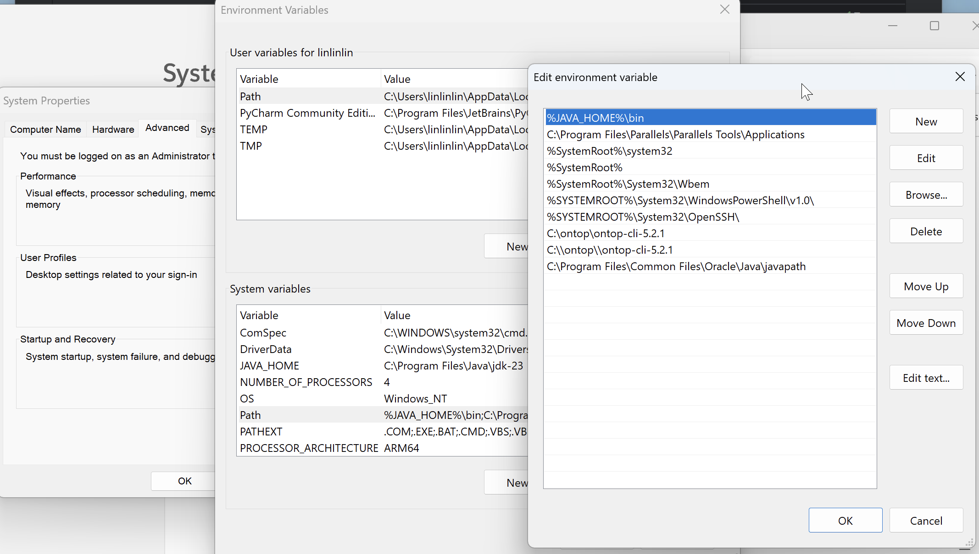

### Specify the JDK path

Force the use of the correct JDK path: Manually specify the JDK path in the command line

"C:\Program Files\Java\jdk-23\bin\java" -version

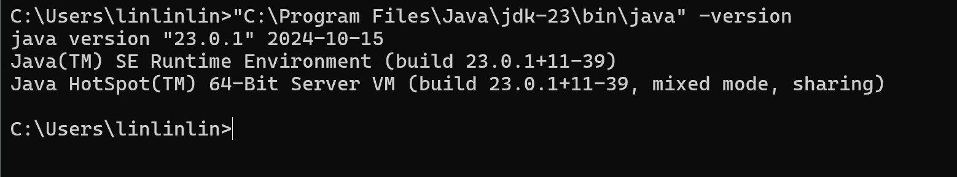

### Install Microsoft Visual C++ Redistributable

Install Microsoft Visual C++ Redistributable  which can be found here:

<https://learn.microsoft.com/en-us/cpp/windows/latest-supported-vc-redist?view=msvc-170>

## Source database modification

Add IS_PROCESSED in the source database. The default value of IS_PROCESSED for the newly added data is FALSE.

In this example,

ALTER TABLE patientinfo ADD IS_PROCESSED BOOLEAN DEFAULT FALSE;

IS_PROCESSED of the data that has been converted to RDF will become TRUE (this operation will be implemented in the Python script).

## No incremental data

If the data in the database has been converted to RDF before, then the IS_PROCESSED of the data in the database will become TRUE. The IS_PROCESSED of the newly added data defaults to FALSE. The script will automatically check whether there is incremental data. If it is found that there is no incremental data, the materialize operation will not be performed. The return is "No new unprocessed data, skip materialize operation".

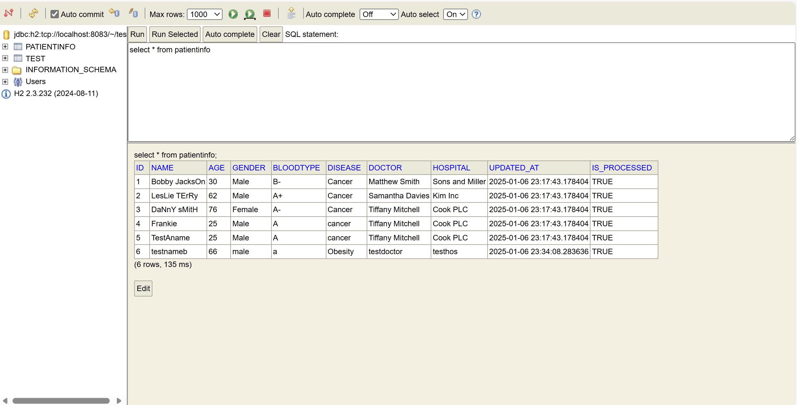

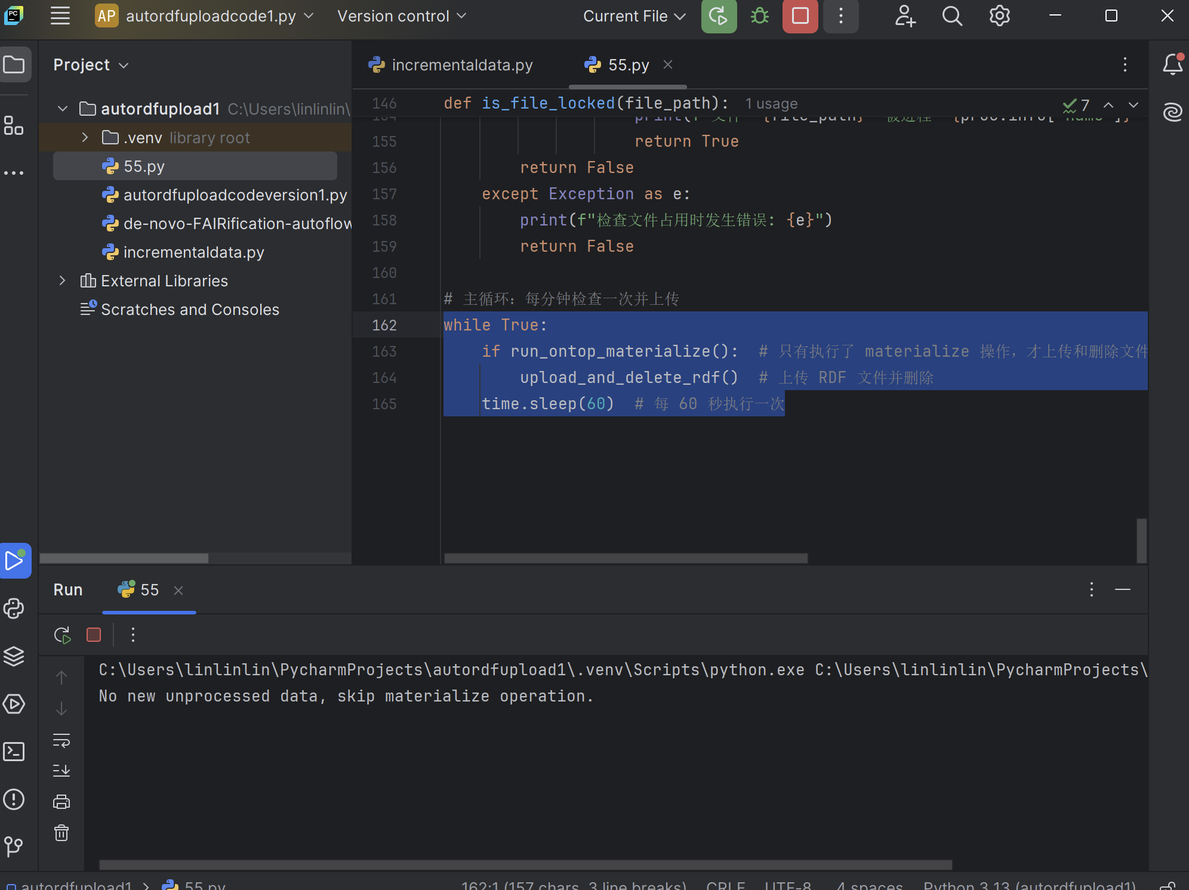

## Incremental data

In this example, insert new data

INSERT INTO patientinfo (ID, NAME, AGE, GENDER, BLOODTYPE, DISEASE, DOCTOR, HOSPITAL)

VALUES (7, 'testnameC', 66, 'male', 'a', 'Obesity', 'testdoctor', 'testhos');

When the script is running and detects new unprocessed data, it will perform the materialize operation and return information such as how many data were executed this time and whether the upload was successful.

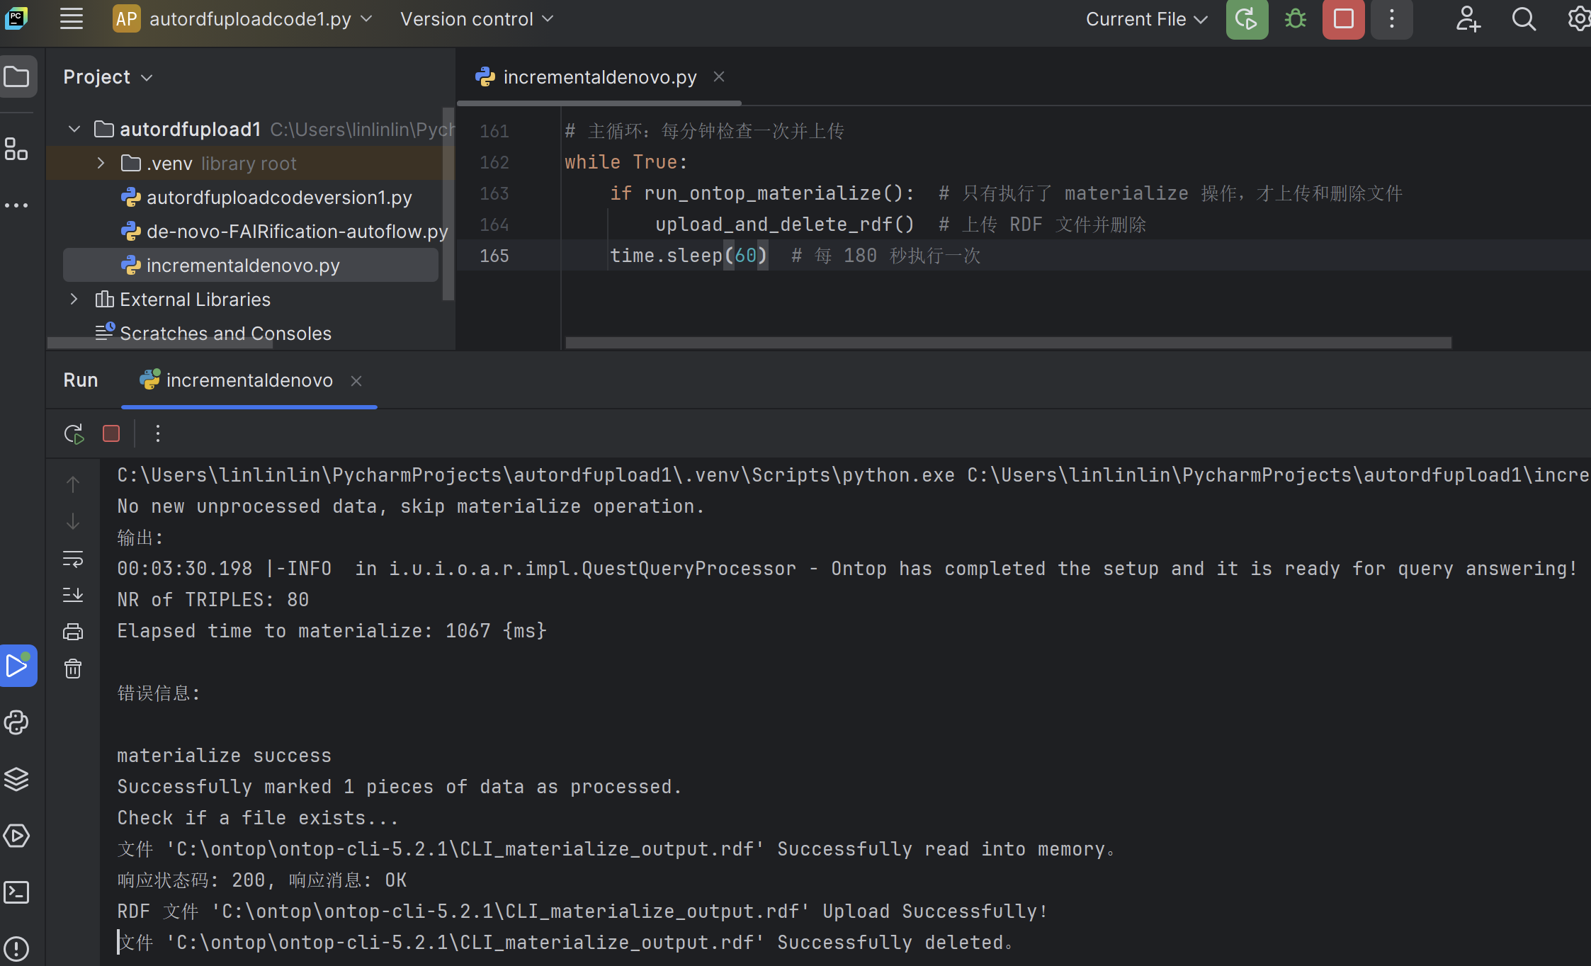

## Real-time monitoring

The script I wrote is currently executed once a minute to ensure that data can be converted to RDF in real time, thus achieving de novo FAIRification. This parameter can also be adjusted.